SENIOR SIX TERM 1
TOPIC 1/2: Equilibria II
Topic competency: The learner applies principles of physical equilibria and colligative properties to analyse and predict changes in physical systems, including phase transitions and effects of solute concentration on solution behaviour, in scientific and real-world contexts.
Phase equilibrium
A phase is a homogenous physical state into which a substance can exist; for example, solid, liquid and vapor/gas

Factors affecting the phase of a substance
These include temperature and pressure. By varying temperature and pressure, it is possible to convert solid into a liquid or gas and the vice versa or a liquid into a gas or a gas into a liquid.
A plot of vapor pressure against temperature of a substance in the liquid, gas or solid state yield graphs called phase diagrams.

There are three forms of phase diagrams:
- Form A is shown by a substance such as water which is accompanied with a decrease in volume when they melt or accompanied with increase in volume when they solidify.


Temperature

Vapor
pressure

solid

vapor

liquid

O

C

A

B

Form A

- Form B is shown by a substance such as benzene that is accompanied with an increase in volume when they melt

Form B

Temperature

Vapor
pressure

solid

vapor

liquid

O

C

A

B

- Phase diagram form C is shown by a substance such as sulphur that exists in different solid form (allotropy)



Form C

Temperature

Vapor
pressure

solid
form I

vapor

liquid

O

C

A

B

solid
form II

At point O, all the three phases are in equilibrium and is called triple point. I.e. triple point is a point of temperature and pressure at which all the three phases (solid, liquid and vapor) are in equilibrium. The temperature and pressure corresponding to the triple point are triple point temperature and triple point pressure respectively.

The triple point temperature Tt⁰C and pressure (Pt) for water and carbon dioxide are given below

Substances | Tt⁰C | Pt
Water | 0.0098 | 0.0060
Carbon dioxide | -56.1 | 5.0

With further rise in temperature the curve OA is obtained and this represents the conditions of temperature and pressure under which the liquid and vapor are in equilibrium.

This curve ceases at A and beyond this point the liquid and vapor are indistinguishable. This point is called the critical point and the corresponding temperature and pressure are called critical temperature (Tc⁰C) and critical pressure (Pc) respectively.
Example Tc⁰C Pc
Water 374 218
CO₂ 37 72.8

OB represents conditions of temperature and pressure at which solid and vapor are in equilibrium.
OC represents conditions of temperature and pressure at which liquid and solid are in equilibrium

Trial 1
The phase diagram of a certain pure substance is given below

Temperature

Vapor
pressure

A

B

C

D
E

Describe the changes in temperature, pressure and phase if any, in each of the following steps in the diagram above.
- A to B
- B to C
- C to D
- D to E

Solution to trial 1
- Pressure remain constant, the temperature is increase, solid at A changes to vapor at B.
- Pressure increases, temperature remains constant, vapor at B changes to Liquid at C (iii) Pressure remain constant, the temperature is increase, Liquid at C changes to vapor at D.
(iv) Pressure increases, temperature remains constant, vapor remains unchanged.

Trial 2
The diagram below shows the variation of vapor with temperature for pure substance.


O

A

C

Temperature (
0
C)

pressure

(
mmHg
)

B

R

Q

(a)(i) On the diagram, indicate the different phases of the substance (1½mk)
(ii) State what happens at point O (1mk)
- High pressure was applied at constant temperature to the phase at point Q. Describe the changes that took place (1½mk)
- The temperature at point R was increased at constant pressure. state what was observed (1mk)

Solution to trial 2
(a)(i)


O

A

C

Temperature (
0
C)

pressure

)
mmHg
(

B

R

Q

Liquid

Vapour

Solid

(ii) solid, liquid and vapour at equilibrium
- changes from vapor to liquid
- solid turns to vapor (sublimes)
Trial 3
- Solid, liquid and vapor
- Vapor and liquid turn into solid
- Liquid turns into vapour

Trial 3

The figure shows the phase diagram for water.

Vapor

pressure

P
3

P
2

P
1

t
1

t
2

t
3

temperature

X

- State the phase that exist at temperature t₂ and P₂ (1½mk)
- What happens to the phase in (i) when pressure is kept constant but temperature is changed from t₂ to t₁ (1½mk)
- State what would happen to phase at X if pressure is changed from P₃ to P₁ at temperature t₃ (1mk)
Solution to trial 3
  - Solid, liquid and gas
  - Liquid and gas turn into a solid
  - The liquid phase turn into a vapour
Trial 4
Fir.2 is a phase diagram for a certain substance.

(
a
)

L
abel the
following on the diagram

B

X

    - the axes
    - the phases
    - critical temperature, t
    - the triple point, O
  - Define the terms
    - critical point
    - triple point
  - Explain what would happen when the substance in point X changes to point B Solution to trial 4


B

X

Solid form A

Vapor

Solid form B

temperature

Pressure

O

t

- (i) Critical point is temperature and pressure beyond which liquid and vapor are indistinguishable
(ii) Triple point is temperature and pressure at which liquid, solid and vapour are in equilibrium
- When temperature is increased and pressure decreased, solid form A changes to solid form B to vapor.

Trial 5
The phase diagram of water is shown below
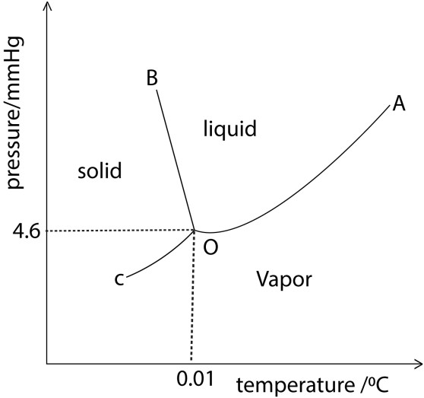
X

  - State what the following points represent., A and O.
  - State what would happen if ice at point X is heated at constant pressure (c) From the diagram, state one condition necessary for ice to melt.

Solution to trial 5
- Liquid, vapour and solid in equilibrium
- Turns into vapor
- High pressure, high temperature
Trial 6
The phase diagram of substance E is shown below
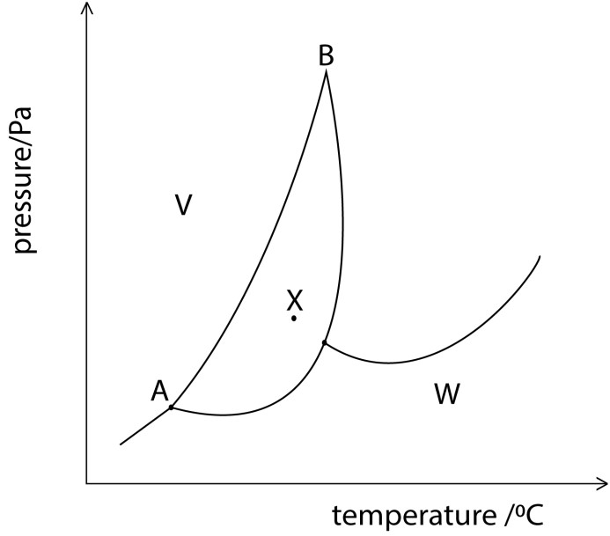
Z

- Identity the phase at W, V, Z
- Name curve AB
- State what would happen to the phase of E at x when pressure is lowered at constant temperature
- State how you would expect the melting point of E to vary with increase in pressure?

Solution to trial 6

- W – vapour
V – solid
Z is liquid
- Transition curve
- Solid turns into vapor
- Melting point increases with pressure

Vapour pressure, Raoult’s law and fractional distillation

Vapor Pressure
All liquids exhibit tendency for evaporation at their surface. For evaporation to occur molecules at the surface require kinetic energy overcomes the intermolecular force of attraction in the liquid state.

When evaporation is in a closed container system, the vapors molecules of liquid remain in contact with surface of liquid. Like gas molecules, vapor molecules also execute continuous random motion. During this motion, molecules collide with each other and also with the walls of the container, losses their energy and returns back to liquid state. This process is called as 'condensation'.

Evaporation and condensation are continuous processes. Hence, after some time at constant temperature, equilibrium is established between the rate of evaporation and rate condensation. At this point, the amount of gas and liquid no longer changes.

Vapor pressure is the pressure exerted by a vapor in thermodynamic equilibrium with its condensed phase (liquid) at a given temperature in a closed system.

The vapor pressure increases with temperature. When the saturated vapor pressure equals the external pressure the liquid boils, thus lowering pressure lowers the boiling point of a liquid whereas increasing external pressure increases the boiling the boiling points of liquids.

The former principle is employed during distillation of at reduced pressure (distillation in a vacuum) to purify substances which would decompose at their normal boiling points.

A plot of the saturated vapor pressure against temperature is shown below
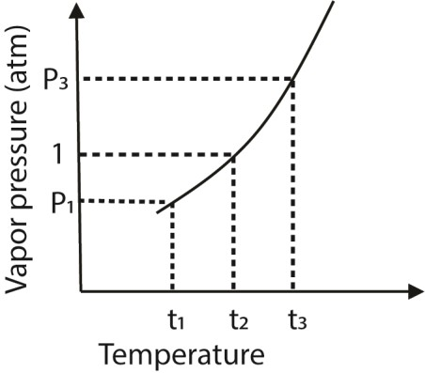

t₁ = boiling point at reduced pressure, P₁.
t₂ = boiling point at 1 atmosphere
t₃ = boiling point at external pressure, P₃ above 1amosphere

Measuring the saturated vapor pressure of a liquid
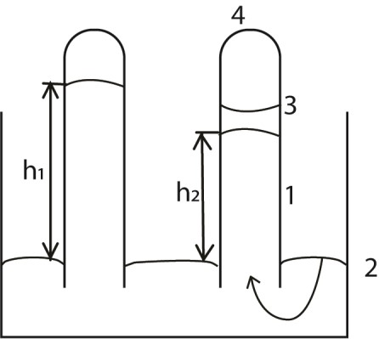

- mercury barometer is set up
- Some liquid is introduced into the barometer
- Liquid float to the top of mercury
- Vapor is formed. The vapor exerts a pressure on the column of mercury
- The level of mercury drops. The difference (h₁-h₂) mm is the saturated vapor pressure of the liquid at this temperature.

The saturated vapor pressure of a liquid can be used to calculate the mass of the liquid that is present in vapor at a stated temperature

Example 1
A 1.00dm³ contains air at 1.01x10⁵Nm⁻² at 0⁰C. After 1.000g of water is introduced into the vessel, the temperature is raised to 90⁰C. Calculate the mass of water that will vaporize. The saturated vapor pressure of water at 90⁰C is 6.99 x 10⁴Nm⁻².

Method
Use the ideal gas equation
PV = nRT
Substitute P= 6.99 x 10⁴Nm⁻²
R = 8.314JK⁻¹mol⁻¹
T = 363K
V = 1.000dm³ = 1.000 x 10⁻³m³

1.99 x 10⁴ x 1.000 x 10⁻³ = n x 8.314 x363

Moles of water vapor, n = 2.32 x10⁻² moles

Mass of water vapor = 2.32 x10⁻² x 18 = 0.417g

Trial 7
Explain the following
(a) Why distillation under reduced pressure often employed in purification of chemical (b) Heat must be supplied to the boiling liquid to evaporate. What happens to this heat?

Solution to trial 7
- Distillation under reduced pressure occurs at reduced temperature thereby protecting heat labile substances from decomposition and it also saves energy.
- Heat of vaporization is required to convert a liquid at its boiling points into vapor

Trial 8
Use R = 8.314JK⁻¹mol⁻¹, 1atm= 1.01x10⁵Nm⁻²
- A liquid of empirical formula CH₂ was vaporized. From 0.108g of the liquid, the volume of the vapor was 50.8cm³ measured at 22⁰C and 9.8kNm⁻². Calculate the molar mass of the liquid.

- By vaporizing 0.100g of a liquid at 100⁰C and 1.01x10⁵Nm⁻², 20cm³ of the vapor were obtained. Find the molar mass of the liquid

Solution to trial 8
(a) PV = 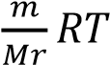; P = 98kNm⁻², T = 273 + 22 = 295⁰C, V = 50.8 x 10⁻⁶ m³.
Then
1000 x 9.8 x 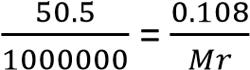 x 8.314 x 295
Mr = 532

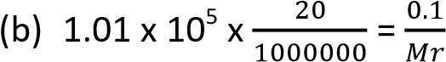 x 8.314 x 373
Mr = 153

Effect of nonvolatile solute on vapor pressure of solvent This lowers the vapor pressure of a solvent

Reason
The presence of the particles of the nonvolatile solute reduces the escaping tendency of the solvent molecules from the surface of the liquid. That is, in the presence of the solute molecules, the probability of the solvent molecules to escape into vapour decreases. Therefore, the vapor above the solution and the vapor pressure of the solution is reduced
The vapor pressure versus temperature diagram for solvent and solution
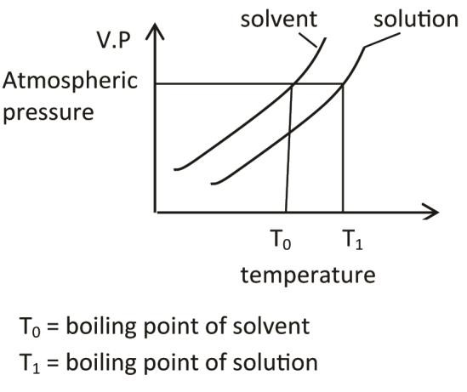
The diagram indicates that nonvolatile solute raises the boiling point of solvent.

Explanation
The presence of nonvolatile solute reduces the vapor pressure of the solvent and therefore, the solution must be heated to higher temperature that of the boiling point of the solvent to make its vapor pressure equals that of atmosphere.

Raoult’s law of relative lowering of vapor pressure

Raoult's law states that the relative lowering of vapour pressure of a solution containing a nonvolatile solute is equal to the mole fraction of the solute in the solution.
If the vapor pressure of the pure solvent at a given temperature, t = P Then vapor pressure of solution = 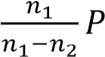
where n₁ = moles of solvent; n₂ = moles of solute and 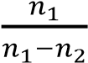 is the mole fraction of solvent.

Trial 9
- Explain the term mole fraction
- Calculate the mole fraction of sodium chloride in aqueous solution containing 10g of sodium chloride per 100g of water. (Na = 23, Cl = 35.5)
- Calculate the boiling point of solution in d(ii) (Kb = 0.52⁰C for 1000g of water

Solution to trial 9
- Mole fraction of a compound in a mixture is the ratio of moles of the component to the total moles of components in the mixture.
- Formula mass of NaCl = 23+ 35.5 = 58.5g
Moles of NaCl = 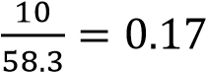
Formula mass of H2O = 1 x 2 + 16 = 18g
Moles of water = 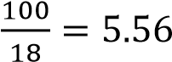
Total moles = 5.56 + 0.17 = 5.73
Mole fraction of NaCl = 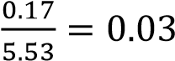
- Mass of NaCl in 100g of water
100g contain 10g
100g contain 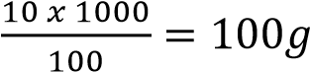
Boiling point elevation
Since 1mole of NaCl dissociates into 2 moles of ions

58.5g (1mole) of NaCl produce an elevation of 0.52 x 2 = 1.04⁰C
100g of NaCl produce an elevation of 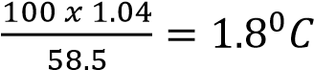

Boiling point of solution = boiling point of water + boiling point elevation
= 100 + 1.8 = 101.8⁰C
Effect of volatile solute on vapor pressure of solvent
Here both the solute and solvent are volatile and therefore each vaporizes and contributes to the vapor pressure above the solution. However, the more volatile component will contribute more to the vapor pressure than the other. Each component lowers the vapor pressure of the other.

Raoult’s Law
The partial pressure of any component at a given temperature in an ideal mixture varies linearly with its concentration. Or
The partial vapor pressure of any component in a mixture at a given temperature is the product of its mole fraction in solution and the vapor pressure of the pure form at that temperature. Or
P_{A} = 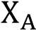 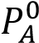
PA = Partial pressure of A in solution 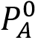 = vapor pressure of pure A
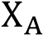 = mole fraction of A = 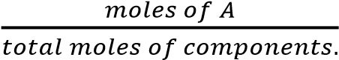

Consider a solution containing two components A and B and the number of moles of A and B are a and b respectively

Then the mole fraction of A, 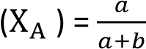 and the mole fraction of B, 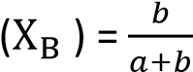

According to Raoult’s Law

P_{t} = 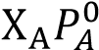 + 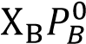 where P_{t} is the vapor pressure of the mixture

The total saturate vapor pressure is the sum of the partial pressure.

An ideal solution is solution that obeys Raoult’s law.

Definition
Partial pressure is the pressure that would be exerted by a component if it alone occupied by the volume occupied by the mixture.

Properties of ideal solution
- The interactions between unlike molecules must are of the same magnitude as those between like molecules.
- Formation of ideal solution does not involve change in volume nor temperature.

Ideal solutions are often obtained by mixing two or more non polar solvents, example Heptane and octane.

A component that has higher vapor pressure at a given temperature is said to be more volatile that a component with low vapor pressure at the same temperature.

A plot of the vapor pressure against composition gives a vapor pressure composition curve.

The vapor pressure composition diagram for an Ideal mixture (A more volatile than B)



P
t

=

𝑃
𝐴

+

𝑃
𝐵

Pure A

Pure B

𝑃
𝐴

𝑃
𝑩

Compositi
on

Vapor
pressure

Composition of the vapor
The composition of the mixture above an ideal solution is obtained from Daltons Law that states that in an ideal mixture of gases which do not react chemically, the total pressure of the mixture is the sum of the partial pressures of the constituent gases.
It follows that the mole fraction of A (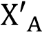) in the vapor 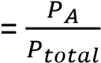
or 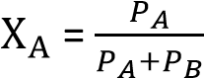

Example 2
- State Raoult’s Law
- A mixture of liquids A and B obey Raoult’s Law. The vapor pressure of A and B are 10.00kNm⁻² and
2.92kNm² respectively at 20⁰C
(i) Calculate the composition of the vapor of a mixture containing 0.5 moles of each liquid at 20⁰C
(3marks)

Solution
(b((i) From, P_{t} 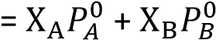
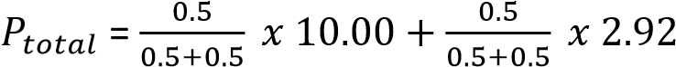
= 6.46kNm⁻²
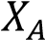 in vapor = 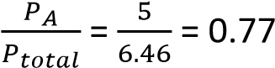
(ii) Which of the liquids is more volatile? Give a reason for your answer
A is more volatile because has a higher vapor pressure than B at the same temperature.

Trial 10
Heptane and octane form an ideal solution
- State Raoult’s law
- Explain what is meant by an ideal solution?
- Calculate the vapor pressure of solution containing 50g heptane and 38g octaneat20⁰C (H=1, C =
12, The vapor pressure of heptane at 20⁰C = 473.2Pa and the vapor pressure of octane at 20⁰C = 139.8Pa)
- Calculate the percentage octane in vapor.

Solution to trial 10

- Raoult’s law states that the partial pressure of a component in a mixture is a product of mole fraction and its vapor pressure of pure component.
- An ideal solution is a solution that obeys Raoult’s law, it has uniform forces of attraction between like and unlike molecules; its formation produces no change in temperature and volume.
- Formula mass of heptane, C₇H₁₆ =12 x 7 + 16 = 100 Moles of heptane = 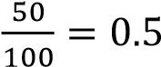
Formula mass of heptane, C₈H₁₈ =12 x 8 + 18 = 118
Moles of heptane = 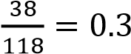
Total mole = 0.5 + 0.3 = 0.8

Total vapor pressure = 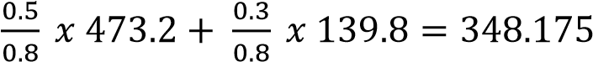

- Mole fraction of octane in vapor = 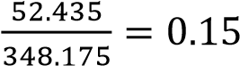

Raoult’s Law and fractional distillation
When the vapor pressure of a liquid equates atmospheric pressure, the liquid boils. Liquid or mixtures with high vapor pressure have lower boiling points than liquids or mixtures with lower vapor pressure. Actually liquids with low vapor pressure have to be heated to higher temperatures in order to bring their vapor pressures equals to atmospheric pressure to boil.

Consider two components A and B
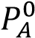 = 500mmHg 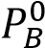 = 100mmHg

Suppose A and B are mixed such that, the solution contains 20% A at a fixed temperature and we assume Ideal behavior.
P_{A} 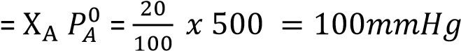
P_{B} 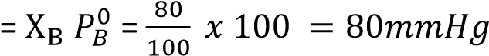
P_{total} = P_{A} + P_{B} = 100+ 80 = 180mmHg

The composition of the vapor above the solution is obtained using Dalton’s Law of partial pressures; P_{A} = X_{A}P_{t}, where P_{A} is the partial pressure of component A and P_{t} is the total pressure. 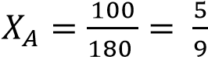 and 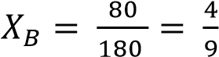

It is observed that the vapor contains more of the more volatile component than the less volatile component B compared what was contained in the liquid mixture.

If the vapor is condensed, the distillate will have the same composition as the vapor and its total vapor pressure will be
P_{t} = 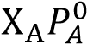 + 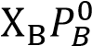
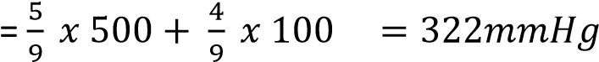

Composition of distillate II will have the same composition as the vapor above

Again if this vapor is condensed into distillate III, the composition of the vapor of the distillate will be

The composition of the more volatile component keeps on increasing on every successive distillation; and if the procedure is repeated a number of times, pure vapor of the volatile component is eventually obtained leading to complete separation.
In practice, it is more convenient to perform distillation at constant pressure rather than constant temperature. The various steps in the distillation are better illustrated on the diagram below



a

b

Key

a = Vapor composition curve

b =

Vapor composition curve

Temp.

Pure A Z Y X Pure B

Composition

T
1

T
2

L

V
1

V
2

The lower curve shows the variation of boiling point of the liquid as distillation progresses.
Suppose the mixture to be distilled has composition X (20%A, 80%B) this mixture is represented by L on the diagram above. The boiling of this liquid commences at a temperature T₁. The vapor given off at T₁ has a composition represented by V₁. When this vapor is condensed, the resultant liquid (composition Y) will be richer in the more volatile component A, and thus boils of at a lower temperature T₂. The vapor given of at this temperature has composition V₂. If this vapor is condensed a liquid of composition Z is obtained.
By repeating the process, a sufficient number of times, we can obtain pure A. i.e. we can achieve complete separation of components
The number of distillation required to obtain the two pure components from equal proportions of the two components depend on the differences in their boiling points. Such a separation of two completely miscible liquids by utilization of differences in their boiling points is known as fraction distillation. However, the method just described above is slow and yield only small amounts of the pure components. In practice fractional distillation is carried out efficiently at constant pressure rather than at constant temperature with the help of a fractionating column (see below). In this case re-distillations are combined in one operation.
During distillation the temperature decreases progressively from bottom to top of the column and the ascending vapor is partially condensed. Condensation of the vapor is effected by the large surface area of the glass pieces or beads and also by the liquid already condensed. The vapor of the less volatile component condenses more readily than those of the more volatile component and return into the flask. Therefore, the higher the vapor ascends in the column the richer it is in the more volatile component in the end, the two components will be able to separate.

Fractionating column
These are various forms and one of them is shown below

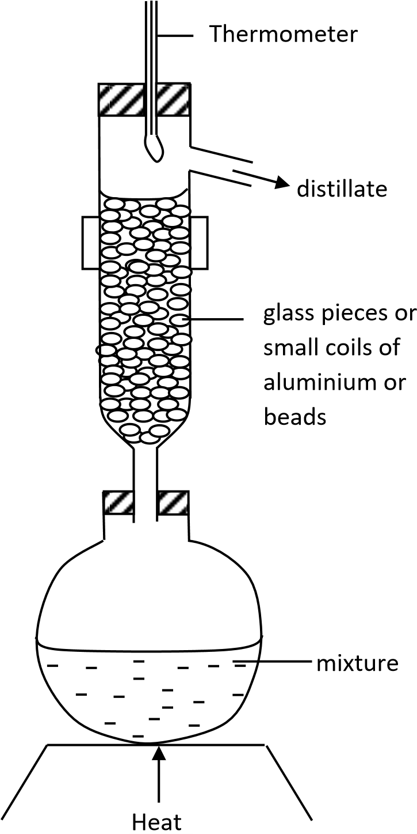

Example 3
The diagram below shows the boiling point composition of a mixture of liquid X and Y.


M

P

Q

Temp.

0
Z
1

Mole fraction of X

N

- Identify curves P and Q and points M and N (4marks)
  - Vapor composition curve
  - Liquid composition curve
  - Boiling point of Y
  - Boiling point of X
- Which of the liquids is more volatile? Give a reason for your answers
Y because it has lower boiling point and hence high vapor pressure.
- Describe what happens when the liquid of composition Z is boiled (4MKS)
The vapor coming off will contain more Y and the residue will contain a higher proportion of X
- Explain how the principle in (iii) can be used to separate liquid mixtures by fractional distillation

If the vapor from (iii) is condensed, a liquid that contains more Y than in a liquid of composition Z is obtained.
Evaporating the distillate in (iii) gives a second distillate which is even richer in Y, than the distillate in (iii). This process of boiling a liquid of any composition and subsequent condensation of the vapor eventually give a vapor and hence a distillate of pure volatile component Y, the residue in the distillation flask will be the less volatile component X.

Trial 11
Compound A (bp 272⁰C) and compound B (bp 399⁰C) form an ideal solution
- sketch a labeled boiling/composition diagram for the mixture
- Using the diagram describe and explain how pure B can be obtained from a mixture containing 50% of B
- Sketch a vapor pressure composition curve of a mixture of A and B

Solution to trial 11
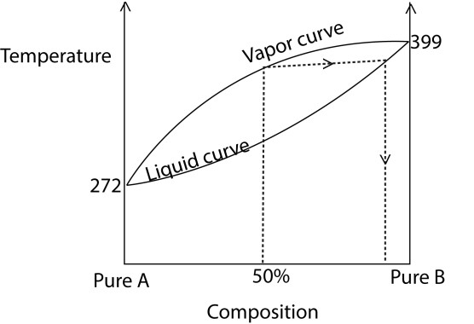
(i)

(ii) When the mixture that contain 50% is distilled, the residue retains high proportion of B. continued distillation of the residue finally produces pure B as the final residue.

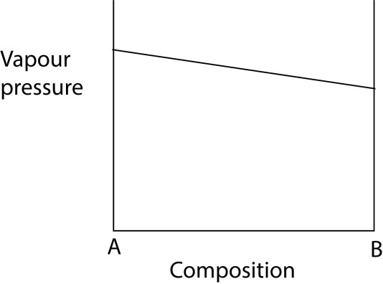
(iii)

Trial 12
(a) (i) State Raoult’s law and mention its limitation (3marks)
- Sketch a diagram of boiling point against composition of two liquids that obey Raoult’s Law.
- Discus with aid of a diagram (ii) above what would happen when a typical mixture in (ii) above is factional distilled.

Solution to trial 12
(a)(i) Raoult’s law states that the partial pressure of a component in a mixture is a product of mole fraction and its vapor pressure of pure component.
Limitation of Raout’s law
- There must be uniform attraction between like and unlike molecules
- Formation of mixtures that obey Raoult’s law should not involve change in temperature nor volume.
(ii)
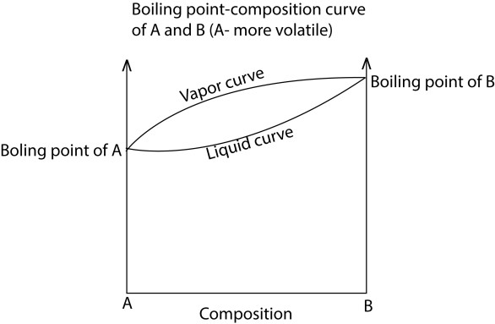
(ii) On fractional distillation the more volatile component(A) is obtained as a distillate while the residue is the less volatile component (B).

Deviations from Raoult’s law
A solution is said to deviate from Raoult’s law when the adhesive and cohesive forces of attraction are not uniform between the two liquids molecule; consequently its vapor pressure (actual) differs from that calculated using Raoult’s law (ideal condition).

Positive deviation from Raoult’s law
Positive deviation from ideality is said to occur when the vapor pressure of the mixture is higher than that of ideal solution
i.e. 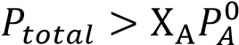 + 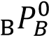

Causes of positive deviation
Unlike molecules interact (attract) with one another less strongly than like molecules do. i.e A↔B A↔A or B↔B
In this case 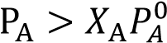 and 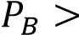 and therefore 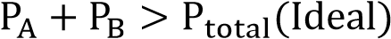

Vapor pressure /composition diagram for a solution which deviate positively (A more volatile than B)


ideal

vapor
pressure

𝑃
𝑩

Pure A

Pure B

𝑃
𝐴

maximum in VP

Composition

Actual

NB: maximum in vapor pressure forms towards the more volatile component.

Boiling point versus composition for a mixture that deviates positively at constant pressure



Key

a = Vapor composition curve

b =

Vapor composition curve

a

b

Temp.

Pure A

Pure B

Composition

minimum
bpt. mixture

A maximum in vapor pressure produces a minimum in boiling point. When such a mixture that shows a positive deviation from ideality is distilled, a minimum in boiling point will be observed at certain composition and at this point the mixture has the same composition as the vapor above it. And further separation of the mixture into either component will be impossible. The mixture corresponding to this minimum boiling point is called azeotrope and the corresponding temperature is called azeotropic temperature.

Definition
An azeotrope is a mixture which has the same composition as it vapors and boils at constant temperature.

NB. Mixtures that deviate positively from Ideality are often obtained by mixing a polar and a non-polar solvent, example, methanol and cyclohexane. It is also observed that that the azeotrope has a higher composition of the most volatile component.

Examples of solution that show positive deviation are:-
- Benzene and methanol,
- Carbon disulfide and acetone,
- Chloroform and ethanol.

Formation of solution that deviates positively from Raoult’s law is accompanied with absorption of heat (cooling) and expansion in volume.

Example 4
Ethanol (bpt. 78.5⁰C) and tetrachloromethane (bpt.76.8⁰C) form an azeotropic mixture of boiling point
65.0⁰C.
- What is meant by azeotropic mixture? (2marks)
- Draw a boiling point diagram for the ethanol-tetrachloromethane mixture (2marks)
(You will notice that ethanol and tetrachloromethane mixtures deviate positively because the boiling point of the azeotrope is lower than that of either component; the boiling composition curve for a mixture that shows positive deviation is required)


a

Key

a = Vapor comp
osition curve

b =

Liquid composition curve

b

Temp.

Pure Pure

tetrachlomethane

ethanol

Composition

bpt.
CCl
4

bpt.
ethanol

- Explain why ethanol and tetrachloromethane form an azeotropic mixture (2marks)
The forces of attraction between like molecules (i.e. ethanol molecules or tetrachloromethane molecules) are stronger than those between unlike molecules (ethanol -tetrachloromethane molecules probably because tetrachloromethane interferes with formation of hydrogen bond in ethanol while ethanol disrupts the van der Waal forces of tetrachloromethane. Therefore, molecules of each liquid in the mixture tend to escape into vapor phase more easily than those of pure components. This makes the total pressure of the mixture higher than that expected from Raoult’s law.

Trial 13
- State Raoult’s law (2marks)
- Draw the vapor pressure/composition curve for mixtures of methanol (more volatile) and cyclohexane and explain the shape of the curve with reference to Raoult’s law (8marks)

Solution to trial 13

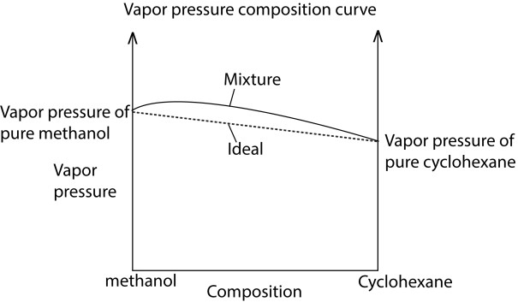
The vapor pressure of the mixture is higher than expected because cohesive forces are higher than adhesive forces. This promotes evaporation of either component.

Trial 14
- State Raoult’s law.
- Methanol and cyclohexane form a mixture that deviates from Raoult’s law. The data below concerns a mixture of methanol and cyclohexane. The normal boiling points of cyclohexane and methanol are 81 and 65⁰C respectively.
Boling  point of the mixture (⁰C) | Mole fraction of  methanol in the liquid mixture | Mole fraction of  methanol in the vapor above mixture
70  60  55  57  61 | 0.12  0.31  0.50  0.82  0.94 | 0.27  0.47  0.56  0.69  0.83
- Plot a boiling point-composition diagram for the mixture, labeling clearly the liquid-composition and
vapor composition curves. (5marks)
- From your graph state the composition of the azeotropic mixture (1mark)
- Name the pure liquid obtained when a liquid mixture containing one mole of cyclohexane and nine
moles of methanol is factional distilled (1mark)
- State how the mixture deviates from Raoult’s law. (1mark

Solution to trial 15
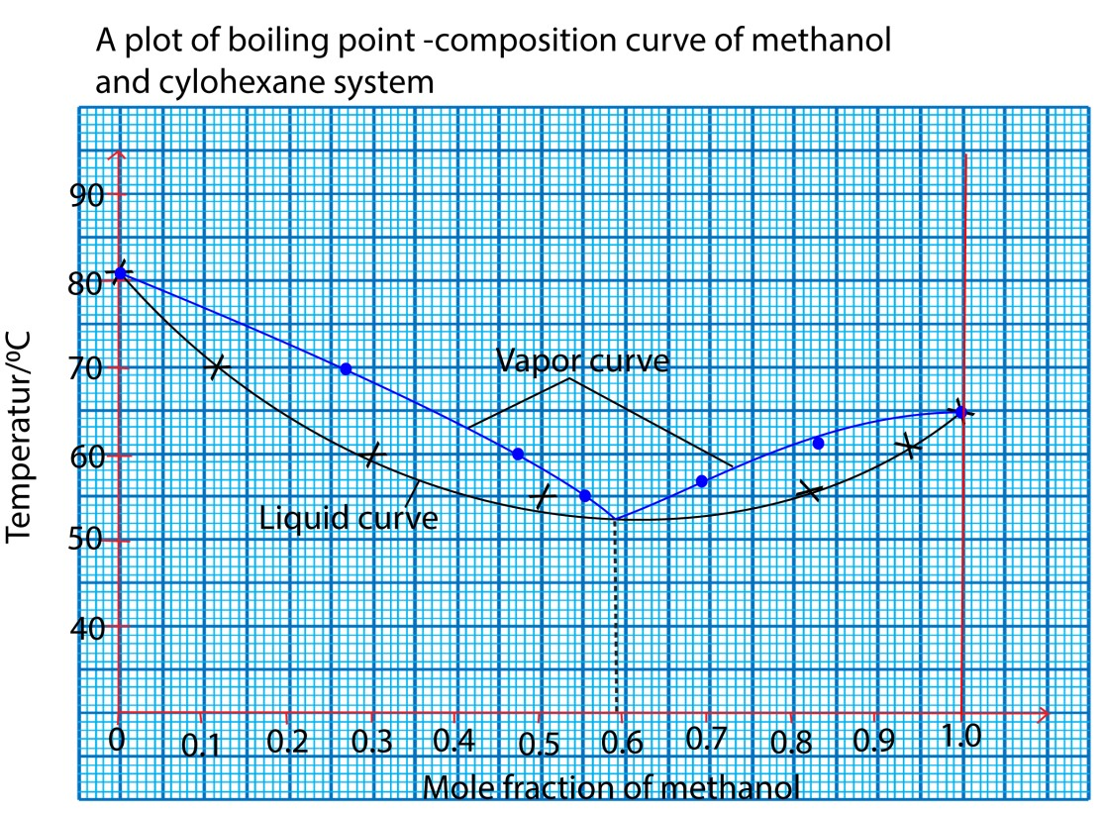
(i)

- Percentage of methanol in azeotrope = 59
- Methanol
- Positive deviation

Negative deviation
Negative deviation from ideality is said to occur when the vapor pressure of the mixture is lower than that of ideal solution.
i.e. 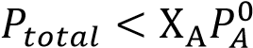 + 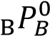

Causes of negative deviation
Unlike molecules interact (attract) with one another more strongly than like molecules do.
i.e A↔B A↔A or B↔B

In this case 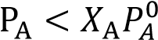 and 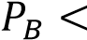 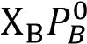 and therefore 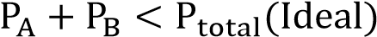 Vapor pressure /composition diagram for a solution which deviate negatively (A more volatile than B)


Actual

Ideal behavior

𝑃
𝑩

Pure A

Pure B

𝑃
𝐴

minimum in VP

Composition/mole fraction

vapor
pressure

ideal

mixture

NB: minimum in vapor pressure forms towards the less volatile component.

An example of a mixture showing negative deviation is that of propanone (CH₃COCH₃) and chloroform (CHCl₃); and water and hydrochloric acid.

Usually mixtures showing negative deviation are obtained by mixing two polar compounds. The negative deviation in this case is due to hydrogen bonding between CHCl₃ and CH₃COCH₃


C

Cl

Cl

Cl

H

O=C(CH
3
)
2

hydrogen bond

Mixtures that deviate negatively from Raoult’s law form a zeotropes with boiling points higher than those of either of their components.

Boiling point versus composition for a mixture that deviates negatively at constant pressure (A more volatile than B)



Key

a = Vapor composition curve

b =

Vapor composition curve

Temp.

Pure A

Pure B

Composition

maximum
bpt. mixture

b

a

Formation of a solution that deviates negatively from Raoult’s law is accompanied with evolution of heat and contraction of volume.

Reasons why azeotropes are not compounds
(i) Can be separated by physical means (ii) Their composition varies with pressure.
(iii) Cannot be represented by a chemical formula

Methods of separating azeotropic mixture
- Adding a substance that reacts and removes one component. e.g. CaO reacts and removes water from azeotrope of ethanol and water
- Distillation with a third substance e.g. benzene in rectified spirit
- Fractional crystallization
- solvent extraction
- adsorption

Example 5
(a) State Raoult’s (3marks)
A mixture of ethanoic acid (bpt. 118⁰C) and pyridine (bpt. 123⁰C) show negative deviation from Raoult’s law
(i) Draw the vapor pressure /composition curve for the mixture of ethanoic acid and pyridine and indicate the line for ideal behavior (4marks)
Solution
To draw the correct diagram, the following should be put into account
- ethanoic acid with lower boiling point has higher vapor pressure
- The minimum boiling point occurs to the composition containing more pyridine (the less volatile)

than ethanoic acid.

𝑃
𝒑𝒚𝒓𝒊𝒅𝒊𝒏𝒆

Pure

ethanoic acid

𝑃
𝐶𝐻
3
𝐶𝑂𝑂𝐻
⬚

Composition/mole fraction

vapor
pressure

Pure

pyridine

mixture

ideal

- Explain the a shape of the curve in relation to Raoult’s law
  - the curve for the mixture lies below the line for ideal behavior
  - this is because the attraction between the molecules of ethanoic acid and those of pyridine are greater (stronger) than those between ethanoic acid-ethanoic acid or pyridine –pyridine molecules
  - pyridine molecules are held by weak van der waal forces
  - ethanoic acid molecules are associated with hydrogen bonds
  - when ethanoic acid and pyridine are mixed, intermolecular hydrogen bonds are formed between ethanoic acid and pyridine molecules which are stronger than the bonds in pure or equal to those in pure ethanoic acid
  - consequently, the escaping tendency of individual molecules of either component is reduced, leading to reduced vapor of solution of the mixture Trial 16
The diagram below shows the vapor pressure-composition for water-methanoic acid at constant temperature.


B

%
100

H
2
O

A

vapor
pressure

100
%

HCOOH

C

D
%
77.5

HCOOH

X

Y

(a)(i) What do the points A and B represent (ii) What does the curve AYB represent?
- What phases exist in areas C and D?
- Explain the shape of the graph (4marks)
- Explain the changes which would take place if a liquid of composition x was fractional distilled.

Solution to trial 16

- (i) A – vapour pressure of pure water
B – Vapor pressure of methanoic acid
  - vapor pressure of the mixture
  - C- vapor
D – liquid
- Vapor pressure of the mixture is less than ideal because adhesive forces are higher than cohesive forces which reduce evaporation and vapor pressure.
- Distillate: water
Residue: azeotrope

Trial 17
  - State Raoult’s law
  - A mixture of liquid Y and Z obeys Raoult’s law. If the vapour pressure of Y and Z are 9.50kNm⁻² and 3.20kNm⁻² respectively at 20⁰C.
    - Calculate the composition of the vapour containing 0.5 moles of each liquid at 20⁰C. (04marks)
    - State which of the two liquids is more volatile. Give a reason for your answers. (02marks) (c) The boiling points of y and Z are 368⁰C and 395⁰C respectively.
    - Sketch a labeled boiling point-composition diagram of the mixture of liquids (03marks)
    - Using the diagram, describe how pure Z can be obtained from a mixture containing 50%
Z. (05marks)
- Explain why some liquids show negative deviations from Raoult’s law. (03marks)
- If the mixture of liquids Y and Z in (b) was to deviate negatively from Raoult’s law, sketch a labeled boiling point-composition diagram for the mixture (02marks)

Solution to trial 17 (a) (i)
Pt = X_{Y}P⁰_{Y} + X_{Z}P⁰_{Z}
= 0.5 x 9500 + 0.5 x 3200
= 4750 + 1600
= 6350
Mole fraction of Y in vapor 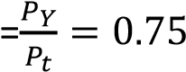
Mole fraction of Z in vapour = 1 – 0.75 = 0.25

(ii) Y is more volatile because it has higher vapour pressure at the same temperature.

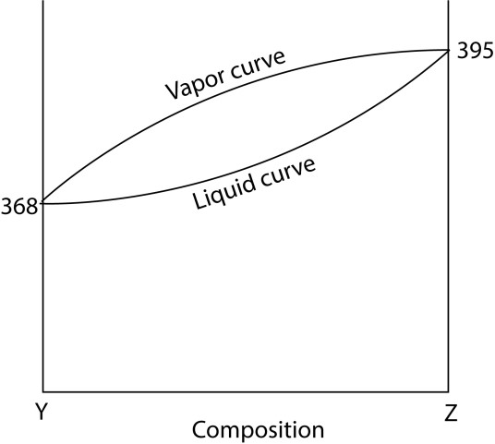

- (i)
Vapor
–

pressure composition
cur
ve of y and Z

(ii) When the mixture that contain 50% is distilled, the residue retains high proportion of Z. continued distillation of the residue finally produces pure Z as the final residue.
- Adhesive forces are stronger than cohesive forces which reduce the rate of evaporation, vapor pressure and increase the boiling point (d)

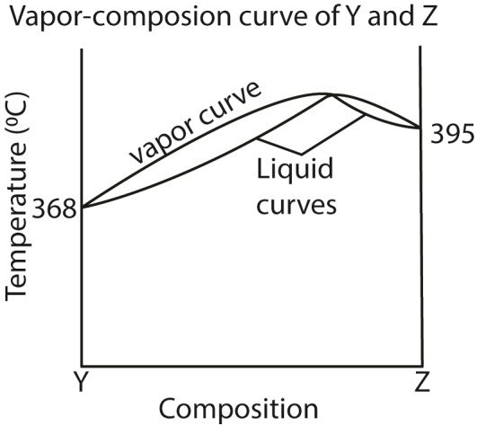
NB the maximum in boiling points must be higher than the boiling points of Y and Z and is nearer to Z (the less volatile component) than to Y

Trial 18
- State three reasons why azeotropes are considered to be mixtures and not compounds ( 1 ½ marks)
- The total vapour pressure of a mixture of propanone and trichloromethane and the mole fraction of trichloromethane at constant temperature are given in the table below
Mole fraction of trichloromethane | 0.0 | 0.2 | 0.4 | 0.6 | 0.8 | 1.0
Total vapour pressure of mixture  (mmHg) | 347 | 305 | 267 | 244 | 256 | 293
  - Plot a graph of total vapour pressure of the mixture against the mole fraction of trichloromethane (03marks)
  - Using the graph deduce how the mixture deviates from Raoult’s law. Give a reason for your answer (02marks)
  - Explain the causes of the deviation you have stated in (b)(ii) (1 ½ marks) (iv) Determine the composition of the azeotropes (01marks)

Solution to trial 18
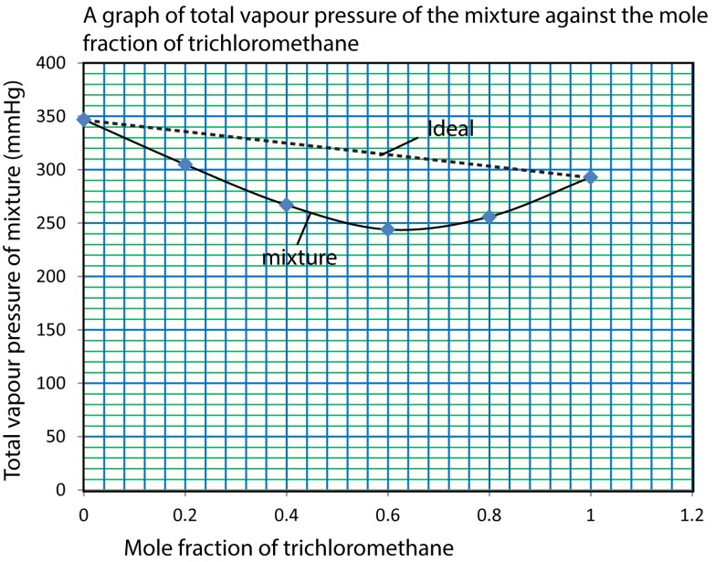
(i)

- Negative deviation because vapor pressure of the mixture is less than that of ideal
- Adhesive forces are stronger than cohesive forces which reduces the rate of evaporation of either component
- Mole fraction of trichloromethane in azeotrope = 0.6

Trial 19
(a) Explain why a solution containing 2.5g of glucose, C₆H₁₂O₆, in 100g of ethanol boils at 83⁰C at
760mmHg pressure whereas pure ethanol boils at 78^{0C} at the same pressure. 3 ½ marks) (b) Using the data in (a), calculate the molar boiling point constant, Kb of ethanol. (4marks) (c) The figure below shows boiling point composition curve the benzene-ethanol system.
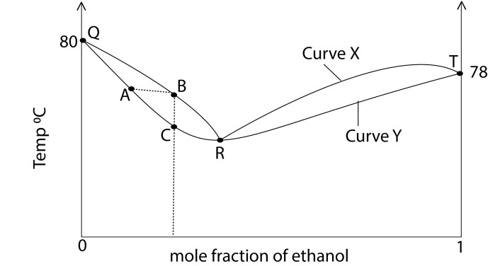

- Identify curves A and Y, and point R (03marks)
- A mixture at point R was boiled, state what happened to its composition. (01 mark)
- State the relationship between A, B and C. (02marks)
- Explain the shape of curve Y, between T and R. (03 marks)
- Draw a labeled diagram to illustrate the vapour pressure- composition diagram for benzene-ethanol system.

Solution to trial 19

- The nonvolatile glucose molecules occupy part of the surface of ethanol reducing evaporation tendency of ethanol molecules and vapor pressure of the solution drops. Thus, the solution has to be heated to a temperature higher than the boiling point of the pure ethanol in order to boil.
- Relative formula mass of glucose, C₆H₁₂O₆ = 12 x 6 + 12 x 1+ 16 x 6 = 180
Boiling point elevation = 83 – 78 = 5⁰C
Mass of glucose in 100g of ethanol
100g contain 2.5g
1000gof ethanol contains 25g

Boiling point elevation constant
25g cause boiling point elevation of 5⁰C
180g of glucose cause elevation Kb = 36⁰Cmol⁻¹kg⁻¹.
- (i) X = vapor curve, Y= liquid curve, R = azeotrope point
  - Composition does not change
  - A liquid of composition A boils to give vapor of composition B which cools to give a liquid of same composition C
  - The curve Y represents the composition of ethanol and the azeotrope.

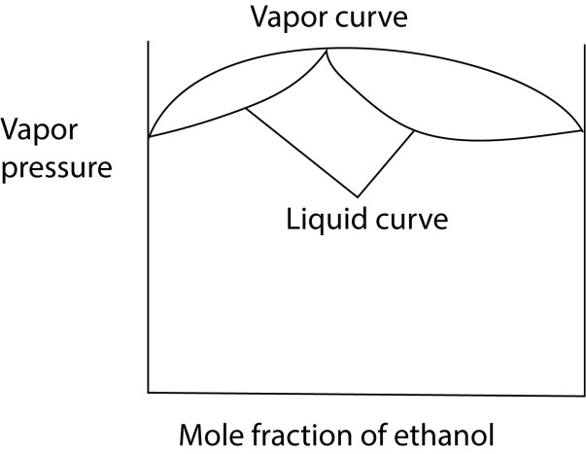
(v)

NB. The maximum in vapor pressure corresponds to the minimum in boiling point.

Trial 20
- State three properties of an ideal solution. (1 ½ marks)
- The vapour pressure- composition curve an ideal solution of liquids A and B is shown below
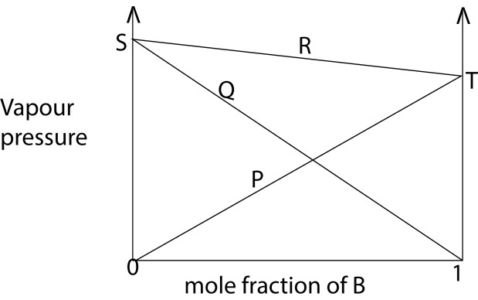
  - Identify line P, Q, and R and points S and T (2 ½ marks)
  - Draw a fully labeled boiling point- composition diagram for a mixture of liquid A and B.
  - State what would be obtained as the distillate and the residue if a mixture containing 40% of A is fractional distilled. (02marks)
- A mixture of benzene and methyl benzene form an ideal solution.
  - Calculate the vapour pressure of a solution containing 1.94g of benzene and 4.6g of methylbenzene at 20⁰C. [ the vapour pressure of pure benzene and pure methylbenzene at 20⁰C are 10.0kPa and 8.2 kPa respectively]
  - Determine the composition of the vapour of the mixture (c)(i) above
- Briefly describe what takes place during fractional distillation. (04marks)

Solution to trial 20
- Has uniform force of attraction between like and unlike molecules
Its formation involves no change in temperature
Its formation involve no change in volume
- (i) Q- partial pressure of A
P – partial pressure of B
  - – total vapour pressure of the mixture
  - – vapor pressure of pure A
  - – Vapour pressure of pure B
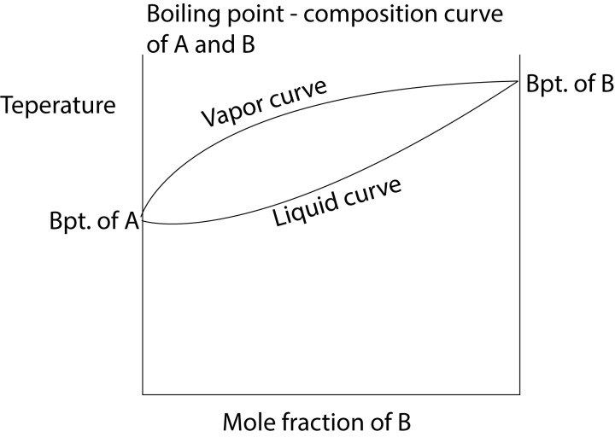
(ii)

- Distillate is A while the residue is B

(b)(i) partial pressure of chloroform =99.8mmHg
Partial pressure of carbon tetrachloride = 57.2mmHg
- Total pressure = 157 mmHg (c) 36%

Trial 21
- Define the term ‘partial pressure.’
- The vapour pressure of pure chloroform and carbon tetrachloride are 199.1 and 114.4mmHg respectively at 25⁰C.
(Assume that a mixture of the two liquids behaves as an ideal solution and that it contains 0.96 moles of each pure liquid.)
Calculate
(i) The partial pressure of each component in the mixture (2 ½ marks) (ii) Total pressure ( ½ mark)
- Calculate the percentage of carbon tetrachloride in the vapour in equilibrium with the liquid mixture (1mark)

Solution to trial 21
(b)(i) Mole fraction of chloroform = 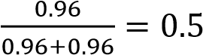
Partial pressure of chloroform = 0.5 x 199.1 = 99.55mmHg
Partial pressure of carbon tetrachloride = 0.5 x 114.4 = 57.2mmHg (ii) Total pressure = 99.55 + 57.2 = 156.75mmHg
(c) Percentage of carbon tetrachloride in vapour = 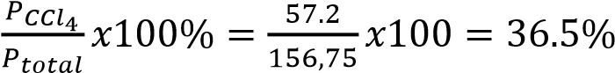

Trial 22
The vapour pressure of a solution containing 1 mole of liquid A and 4moles of liquid B is
0.750atmospheres at a certain temperature

The vapour pressure of pure A and pure B are 0.674 and 0.453 respectively at the same temperature.
- Calculate the vapour pressure of the solution if it behaved as an ideal solution (03)
- State how the solution deviates from Raoult’s law. Give a reason for your answer. (1 ½ mark)
Solutionto trial 22
- Pt = 0.5
- Deviates positively because the vapor pressure solution is higher than what is expected from Raoult’s law/ideal

Trial 23
(a) (i) Define the term constant boiling point mixture (2marks)
It is a mixture with the same composition in liquid and vapor
- Sketch a labeled diagram of the boiling point-composition for hydrochloric acid and water system.
[The boiling points of water and hydrochloric acid are 100⁰C and 85⁰C respectively]

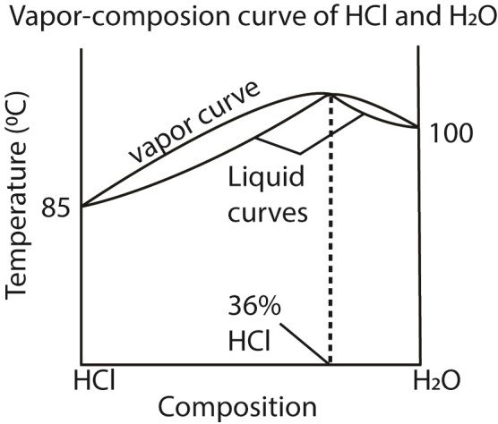

- Describe what would happen if a mixture of 10% hydrochloric acid
The distillate is water
The residue if Azeotrope
- A constant boiling point mixture of hydrochloric acid has a density of 1.18gcm⁻¹. Calculate the volume the acid needed to prepare one litre of 2M hydrochloric acid solution.
(03marks)
Concentration of HCl per dm³ in azeotrope 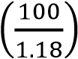cm3 contain 36 g of HCl
1000cm³ contain 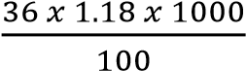 = 424.8gdm⁻³
Molarity of azeotrpe = 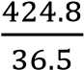 = 11.64M
From C₁V₁ =C₂V₂
11.64V = 1000 x 2
V = 171.8cm³
Hence the required volume is 171.8cm³

- The vapor of ethanol at 20⁰C is 43.6mmHg while that of benzene at the same temperature is
75.2mmHg. The mole fraction of benzene is 0.09 for the mixture of and ethanol at 20⁰C. Calculate
- The vapor pressure of the mixture. (04marks)
Mole fraction of ethanol = 1 – 0.09 = 0.91
Pt = 0.09 x 75 .2 + 0.91 x 43.6
= 6.768 + 39.676 = 46.444mmHg
Hence vapor pressure of the mixture = 46.444mmHg
- The mole fraction of benzene in the vapor. (2marks)
Mole fraction of benzene = 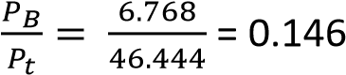

Immiscible liquids
These are liquids that do not form a uniform solution but separate into two layers when mixed.

For these liquids, the total vapor pressure (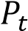) is the sum of the vapor pressure of individual components at that temperature.

i.e. 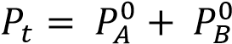 where 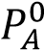 is the vapor pressure of component A

It implies that the vapor pressure of the mixture is usually higher than that of either components and thus the boiling point of the mixture is lower than that of either component.

NB: a liquid boils when its vapor pressure equals that of the atmospheric pressure.

Steam distillation
It is a technique of separating a volatile liquid/substance that is immiscible with water from nonvolatile component at temperature below its boiling point by bubbling steam through the mixture

Principles of separation of mixtures by steam distillation
The substance to be separated by steam distillation should
- be volatile to separate as vapor from nonvolatile substance,
- has relatively high molecular mass to give reasonable amount in distillate
- immiscible with water to be separate from the distillate using a separating funnel and - mixed with other nonvolatile components.

Since the components and water are immiscible, at any given temperature, each contributes its own vapor to the total vapor pressure of the mixture.

So the total vapor pressure of the component and water will be higher than that of either component and thus boils at a lower temperature than that of either water or the component.
Components that can be separated by steam distillation include: amino benzene, nitrobenzene, chlorobenzene, bromobebzene, e.t.c.

Advantages of steam distillation
- Distillation occurs at a temperature below the boiling point of either that of the component or that of water. This is useful if the organic compound is liable to decompose at temperature near its normal boiling point.
- used to determine the relative molecular mass of substance

Disadvantages of steam distillation
a) The distillate will be a mixture of water and the organic liquid, thus another method of separation is required such as a separating funnel. i.e., it is not a complete separation method.


Apparatus for steam distillation

Composition of steam distillate

thermometer

stea
m

heat

mixture

water in

The ratio of the amount of the substance to that of water in the distillate is equal to the ratio of their vapors. If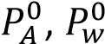 are vapor pressure of A and water and 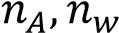 are the moles of A and water in volume
V of the distillate, then
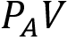 = RT
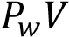 = 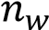RT
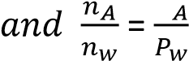
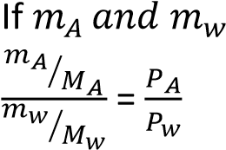 are the masses and 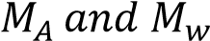 are the molar masses of A and water respectively, then

Taking 100g of the distillate
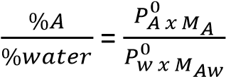
But %water 100 - %A

Example 6
- Aniline (nitrobenzene) is prepared in laboratory by the reduction of nitrobenzene using tin and hydrochloric acid. the mixture is then treated with sodium hydroxide and aniline isolated by steam distillation.
  - What is meant by term steam distillation?
  - Describe briefly how you would perform steam distillation in the laboratory and draw a labeled diagram of the apparatus required (5marks)
  - What is the advantage of using steam distillation to isolate aniline? (2marks)
- At 760mmHg the steam distillation of a certain liquid of molecular mass 45 takes place at 96⁰C. If the vapor pressure of water at the same temperature is 658mmHg; calculate the composition of the distillate as a percentage by mass.

Solution
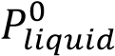 = 760 -658mmHg = 102
Let x be the percentage by mass of the liquid in the distillate, then the percentage of water = 100-x

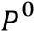
since, 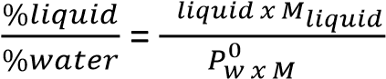
then, 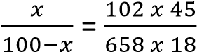
x =27.93%

Therefore, percentage of a liquid in distillate =27.93

Example 7
X was steam distilled at 70⁰C and 760mmHg. The distillate was found to contain 87.5% by mass X. (The
vapor pressure of water at 70⁰C is 234mmHg). Calculate the formula mass of X Solution
V.P of X = 760 – 234 = 526mmHG
% of water = 100 – 87.5 = 12.5%
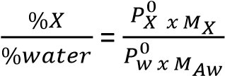
  - 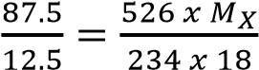
  - 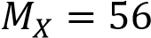

Trial 24
When substance Y was steam distilled at 93⁰C and 750mmHg, the distillate contained 55% of Y by mass. Calculate the relative molecular mass of Y. (the partial vapor pressure of water at 93⁰C is 694mmHg)
[273]

Trial 25
(b)(i) Explain the process of steam distillation (diagram no required) (5marks)
(ii) Name one compound that can be isolated by steam distillation (1mark)
(c) When a compound Y was steam distilled at standard pressure, the distillation temperature was 86⁰C. The vapor pressure of water is 740mmHg. The distillate contained 85% by mass of water. Calculate the relative molecular mass of Y (4marks) [118]

Trial 26
The vapor pressures of water and of an immiscible liquid X at different temperatures are given below

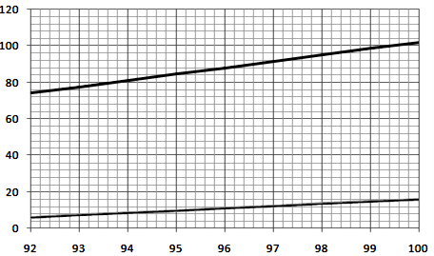

Vapor pressure/kPa

Temperature/
0
C

X

P
0
W
=
88
kPa

P
0
X
=
13
kPa

96.4
0

(a)(i) Construct on the figure above the vapor pressure curve for a mixture of water and X (1mark)
(ii) At what temperature will the mixture boil at the following pressures (1mark) [96.4⁰]
- After distilling at 101kPa pressure for some time the distillate was found to consist of 1.00g of water and 0.480g of X. By using the graph in the figure or otherwise calculate the relative molecular mass of X (3marks)
From the graph P⁰_{W} = 88kPa and P⁰_{X} = 13kPa
Total mass of distillate = 1 + 0.48 = 1.48g
% of water = 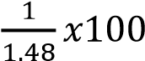 = 67.6%
% of X = 1 – 67.6 = 32.4%

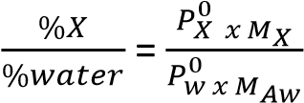
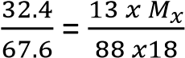
Mx = 58.4

- How will the composition of the distillate change if any during distillation (1mark)
It does not change as long as both components are present in the mixture because they evaporate independently

Trial 27
The vapor pressures (V.P) of water and of an immiscible liquid A at different temperatures are given in the table below:
Temp/⁰C | 92 | 94 | 96 | 98 | 100
V.P of X/kPa | 6 | 8 | 12 | 15 | 17
V.P. of H₂O/kPa | 74 | 80 | 88 | 94 | 101
- On the same axes, plot graphs of vapor pressure against temperature (4marks)
- (i) Determine the vapor pressures of the mixture of X and water at the same temperature given in the table. (02marks)
(ii) On the same axes of the graph in (a), plot a graph of the vapor pressure of the mixture versus the temperature (2marks)
- The distillate obtained from the mixture at 101kPa contained 1.6g of water and 1.1g of X. Calculate the relative molecular mass of X using the information from the graph (5marks)
- (i) Explain the principles in the separation of mixture by steam distillation (5marks)
(iv) State any two advantages of steam distillation (2marks)
Solution to trial 27
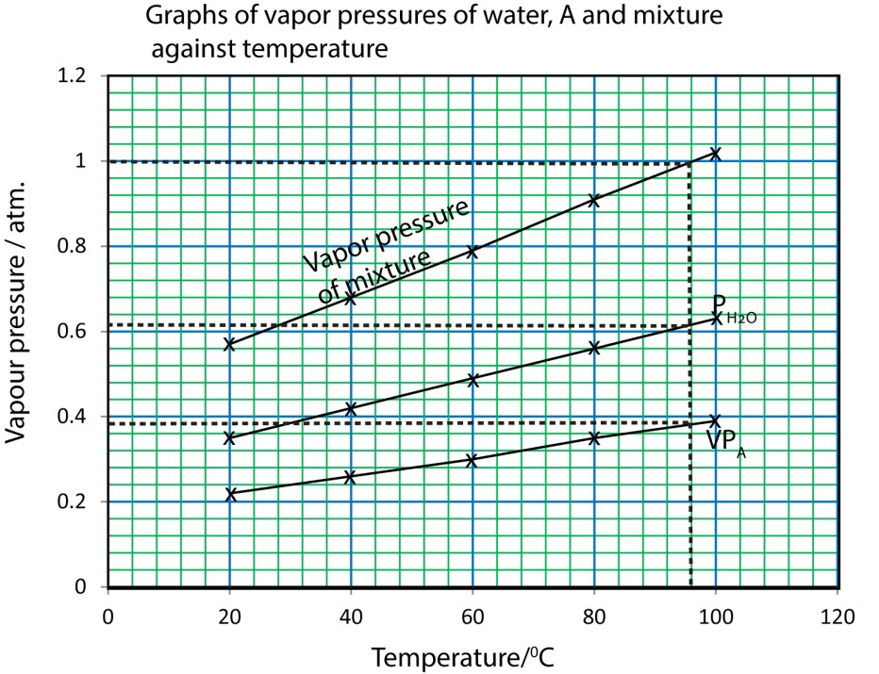
(ii) 130

Trial 28
- (i) What is meant by steam distillation?
(v) Draw a diagram of a setup of the apparatus that can be used to purify steam distillation (03marks)
- (i) state three properties of a substance that enable it to be purified by steam distillation (03marks)
  - Explain how the properties you have stated in (b)(i) enable the substance to be purified by steam distillation (04marks)
  - State the advantages of isolating substances by steam distillation. (02marks)
- The vapour pressure of water (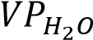) and that of substance A (VP_{A}) at different temperatures are given in the table below
Temperature /⁰C | 20 | 40 | 60 | 80 | 100
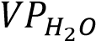 (atm) | 0.22 | 0.26 | 0.30 | 0.35 | 0.39
VP_{A} (atm) | 0.35 | 0.42 | 0.49 | 0.56 | 0.63

  - On the same axes, plot graphs of vapour pressure against temperature for water and substance A.
  - When substance A was distilled in steam at 1 atm. pressure, the temperature of distillation was 97⁰C, and the distillate obtained contained 4.29g of substance A and 1.1g of water.
Using your graph in c(i), calculate the relative molecular mass of substance A. (04marks)
Trial 29
When an amine, Z was steam distilled at 98.6⁰C and 760 mmHg pressure, the distillate contained 25g of water and 7.4g of Z. calculate the relative formula mass of Z.(the vapor pressure of water at 98.6⁰C is 720mmHg). [192]
Trial 30
- When 4.90g of an organic compound X containing carbon and hydrogen only was burnt in oxygen 15.78g of carbon dioxide and 5.38gof water were formed. Calculate the empirical formula of X. (2 ½ mark) [C₂H₃]
- X was steam distilled at 80⁰C and 760mmgH and the distillate was found to contain 90.8% by mass X. (The vapour pressure at 80⁰C is 240mmHg) (i) calculate the formula mass of X (2 ½ marks) [82]
(ii) Deduce the molecular mass of X. [C₆H₁₀]
Trial 31
- Explain what is meant by the term steam distillation (3marks)
- When a compound Y, was steam distilled at standard temperature, the temperature of distillation was 96⁰C. The vapour pressure of water at this temperature was 730mmHg and the distillate contained 74% of water.
Calculate the relative molecular mass of Y (04marks) [154]

Eutectic mixtures
These are mixtures which at constant pressure freeze at constant temperature to give a solid of the same composition.
Similarities between eutectic mixture and pure compound a) both have a sharp freezing point at constant pressure
b) Have the same composition in liquid and liquid

Reasons why eutectic mixtures are not compound a) their composition varies with pressure
- can be separated by other physical methods as distillation and evaporation to dryness
- X-ray analysis shows that eutectic mixtures are not pure compound
- Microscopic analysis shows that eutectic mixtures are heterogeneous, made of a mixture crystals of separate substances
- Chemical properties of eutectic mixtures are those of individual components making up the mixture for example when solder is reacted with dilute hydrochloric acid, tin reacts whereas lead does not.

Conditions necessary for formation of eutectic mixtures
- pure crystals of the components should separate from mixture on cooling.
- The two substance involved must be completely miscible when melted
Consider a solution of NaCl in water; when a solution containing less than 23.3% NaCl is cooled, pure crystals of Ice will separate out at a temperature below 0⁰C. As this occurs the solution become richer in NaCl leading to further depression of the freezing point until about -21 ⁰C. At this temperature the composition of the solution is 23.3% NaCl and further cooling temperature remains constant until both sodium chloride and water have frozen together to form a solid of the same composition.
Alternatively; when a solution containing more than 23.3% of sodium chloride is cooled, NaCl separate out as temperature falls until the concentration of the solution is about 23% and this occurs at about 21⁰C. Here water and NaCl freeze to form a solid of the same composition.
Graphically, the above information can be represented on eutectic diagram below



0

Ice +
saturated

solution

Solution

Solid NaCl

+

saturated
solution

Ice +
Eutectic
mixture

Solid NaCl
+

Eutectic mixture

-
21
0
C

Temp.

23.3
%

% composition of NaCl

The mixture of salt and ice which crystallizes at -21⁰C from either a dilute or concentrated solution is called eutectic mixture and the temperature at which the mixture freezes is called Eutectic temperature.

Other substances that can form eutectic mixtures are
- Tin (mpt. 232) and lead (mpt.227); Eutectic composition is 66% Pb and eutectic temperature 183⁰C.
- Zinc (mpt. 491) and cadmium (mpt. 321⁰C); eutectic composition 75% Zn and temperature 270⁰C.

Example 8
- Explain the following term
  - solubility (3marks)
  - Eutectic mixture (3marks)
- The equilibrium diagram for the sodium nitrate-water system is shown below

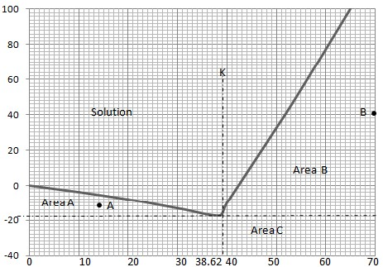
Temp
/
0
C
Percentage by weight of NaNO
3

D

E

F

- State what lines DE and EF represent (2mk)
DE- freezing/melting point of solutions containing less than 38.62% sodium nitrate
EF – solubility curve for solutions containing more than 38.62% sodium nitrate at various temperatures
- Determine the % of sodium nitrate at points A, B and C (3mks)
A: 26% (draw a horizontal line to touch the curve and a vertical line to read the concentration) B: 52%
C: 38.62%
- Name the substances at A, B, and C (4½mk)
A: ice and sodium nitrate
B: solid NaNO₃ and solution
C: Eutectic + solid NaNO₃
(a) (i) What would be observed if a solution having the composition K was cooled slowly
The solution remains in liquid form until -17.5⁰C; here the temperature remains constant until all the liquid has turned into a solid, and then the temperature of the solid falls.
(ii) State two reasons why eutectic mixtures are not compounds.
- they can be separated by other physical means such as evaporation to dryness - their composition varies with pressure

Trial 32
- Define the term eutectic mixture (3marks)
- The table below shows the melting points of various mixtures of tin and lead
%Tin | 0 | 20 | 40 | 70 | 80 | 100
Mpt/⁰C | 327 | 280 | 234 | 193 | 206 | 232
  - Draw a fully labeled diagram for the tin-lead system (5marks)
  - Determine the eutectic temperature and composition of the eutectic mixture (3marks)

- Describe the changes that would take place when a liquid mixture of the above system containing
40% tin is cooled from 400⁰C to 100⁰C (6marks)
- (i) state one application of the tin-lead eutectic mixture (1mark)
  - Name one other pair of metals which can give a similar phase diagram as in(b)(i)
  - State one similarity between a eutectic mixture and pure metal (1mark)
Solution to trial 32
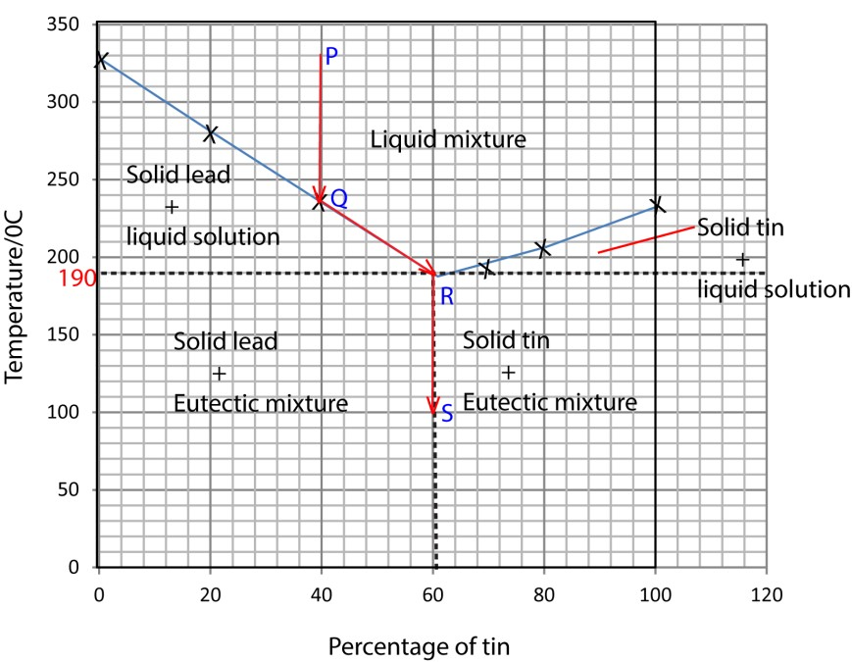
(b)(i)

(b)(ii) Eutectic composition 60% tin,
Eutectic temperature 190⁰C

- The temperature of the liquid falls from 400⁰C to about 235⁰C along PQ (shown on the graph); at Q solid lead crystallizes out and the freezing point of the remaining solution drops along QR as more lead solidifies. At R (190⁰C) the composition of tin will be 60%, temperature remains constant until all the liquid has turned into a solid before the temperature drops further to 100⁰C along RS.

- (i) welding
  - Zn and Cd, Cu and Zn, Ca and Mg,
Pb +Ag
  - both have a sharp melting point
Have same cooling curve
Have the same composition in solid as in liquid

Trial 33
- Define the term eutectic temperature (1mk)
- the melting points of different composition of cadmium and zinc are shown in the table below
% of Zinc | 0 | 10 | 17 | 30 | 60 | 100
Mpt/⁰C | 321 | 295 | 270 | 305 | 360 | 491
- Draw a well labeled melting point-composition diagram for cadmium-zinc mixture
- Explain phase changes which take place if a liquid mixture containing 5% zinc is cooled from 306 to 250⁰C
- 200g of the liquid mixture of composition 5% zinc was cooled to 275⁰C. determine the composition of the remaining liquid mixture at 275⁰C
- Calculate the mass of cadmium in the remaining liquid mixture at this temperature.
(c) Mention three tests which can be carried out on an eutectic mixture to show that it is not pure compound (3marks)

Solution to trial 33
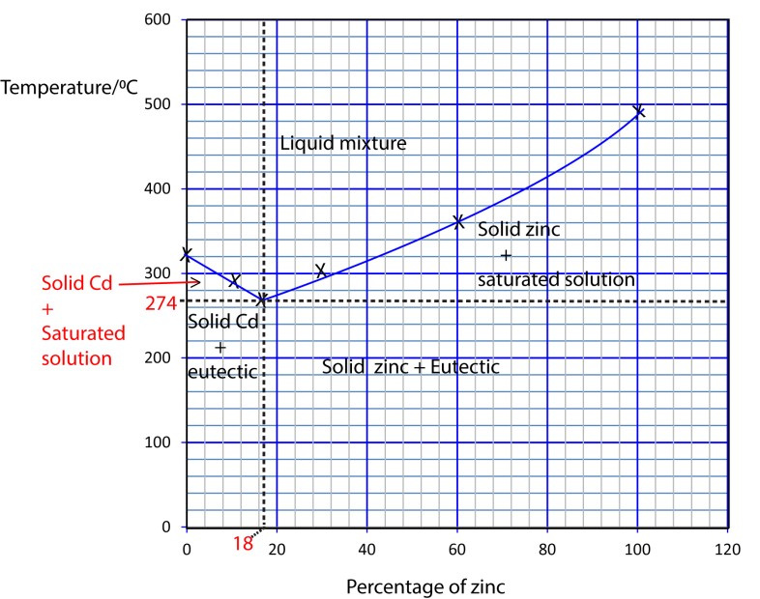
(b)(i)

- The mixture remains a liquid up to about 306⁰C, at which pure solid cadmium starts to crystallize out. The freezing point of the liquid mixture drops to 274⁰C as more pure cadmium solid is removed. At 274⁰C, the composition of zinc becomes 18% Zinc (eutectic composition). The temperature remains constant until all the liquid turns into a solid and finally the temperature of the solid drops to 250⁰C.
- it is 18% zinc and 82% cadmium
- Let the mass of cadmium that crystallize out be X
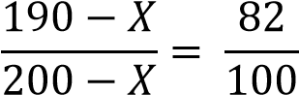
X = 14.3
Total mass of liquid mixture at 275⁰C
200 -14.3 = 185.7

then mass of cadmium = 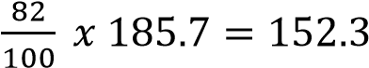

(c) test whether composition changes with pressure
- whether on distillation components separate
- whether using solvent extraction the components separate - whether using chromatography components separate.
- Microscopic examination show that eutectic mixture is a mixture of crystals of separate pure compounds
- properties of eutectic mixture is the sum of the properties of individual components

Trial 34

The phase diagram of a mixture of metals X and Y is shown below
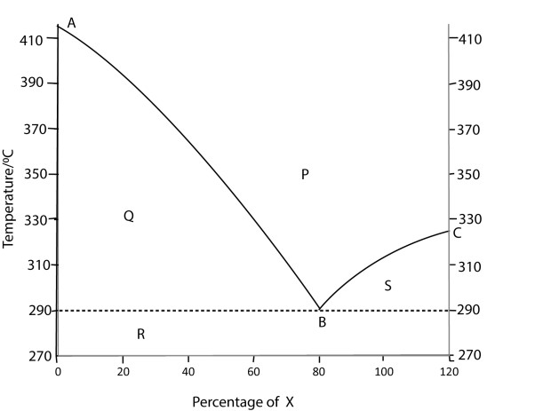
- State how the above curve was obtained (02mark)
- Identify the regions P, Q, R and S. (02marks)
- State what point B represent
- Using the diagram estimate the melting points of X and Y. (01mark)
- Describe what would happen if a mixture containing 50% by mass X and Y is cooled from 410⁰C to 270⁰C. (03marms)
Solution to trial 34
- by determining the freezing points of various mixtures of x and Y.
- P- liquid mixture
  - – solid Y + liquid mixture
  - – solid Y + eutectic mixture
  - – solid X + liquid mixture
- B – eutectic point or temperature and pressure at which eutectic solidify.
- X = 320⁰C; Y = 420⁰C
- – the mixture freezes at 346⁰C.
  - Solid Y crystalizes out
  - Freezing point of solution falls to 290⁰C as the composition of X increases to 80%
  - At 290⁰C, the temperature remains constant as both A and Y solidifies together to form a solid of constant composition.
  - The temperature of the solid falls to 270⁰C

Trial 35
- Define the term eutectic mixture (1 ½ marks)
- The phase diagram for zinc-cadmium is shown below

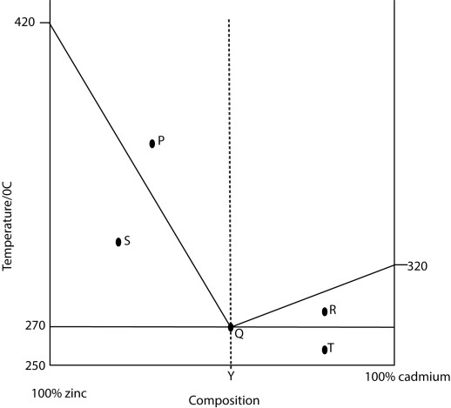
  - State the phases at point P,Q, R, S and T. (2 ½ marks)
  - State what would be observed if a solution of composition Y was cooled slowly
- Give three reasons why eutectic mixtures are not compounds
Solution to trial 35
- P – Liquid mixture
  - solid and liquid mixture at equilibrium
  - – solid cadmium and liquid mixture
  - – solid zinc and liquid mixture
  - solid cadmium and solid eutectic
- Solidifies at constant temperature (270⁰C)to give a solid of constant composition before the temperature falls
- Reasons why eutectic mixtures are not compounds
  - their composition varies with pressure
  - can be separated by other physical methods as distillation and evaporation to dryness
  - X-ray analysis shows that eutectic mixtures are not pure compound
  - Microscopic analysis shows that eutectic mixtures are heterogeneous, made of a mixture crystals of separate substances
  - Chemical properties of eutectic mixtures are those of individual components making up the mixture for example when solder is reacted with dilute hydrochloric acid, tin reacts whereas lead does not.
Solubility
Is the mass of a solute that saturate 100g of a solvent at a given temperature.

A saturated solution is one that contains the maximum amount of solute in it at a given temperature

Super saturated solution contains more solute dissolved in it than could exist if the solution were in equilibrium with the solid.

Experiment to determine solubility of a salt in water (say NaCl)
- 100g of water is weighed out accurately into a flask and the flask is kept at constant temperature by placing it in a water bath with a thermostat.
- The salt is added to the solution until it dissolves no more.
- A measured volume of the solution is withdrawn from the flask, e.g. using a pipette, but making sure that no solid is sucked.
- The mass of the solid in the volume is determined by evaporation to dryness or by titration.
- Finally, the result from (iv) are scaled up to give the mass of a solute in ht e original 100g of water

Application of solubility
- compare solubility of different salts
- Fractional crystallizations
This is based on the difference in solubilities of salts in water.

Example 9
- The table below shows the solubility of salt A and salt B at different temperatures

Temp/⁰C |  | 0 | 10 | 20 | 30 | 40 | 50 | 60
Solubility  g per  100g of  water | Salt A | 13 | 20 | 32 | 45 | 63 | 85 | 110
Solubility  g per  100g of  water | Salt B | 32.5 | 34 | 35 | 36 | 37 | 38 | 39
(i) Plot a graph of solubility against temperature for salt A and B using the same axes (4marks)

A graph of solubility against temperature
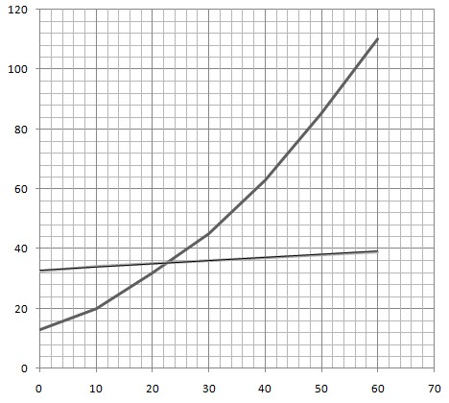(ii) A saturated solution of salt A was cooledfrom45⁰C to 25⁰C. determine the mass of salt deposited

Temperature/
0
C

Solubility g per 100g of water

Salt A

Salt B

(2marks)
Mass deposited per 100g of solution = solubility at 45⁰C – solubility at 25⁰C
72-37 = 35g
- Explain how a pure sample of salt A can be obtained from a mixture containing salt A and B. Name one method that can be used to test for purity of the separated sample

When a saturated solution with A and B at 45⁰C is cooled to 250C, the crystals deposited are richer in A than B. If the crystals are re-dissolved to give a saturated solution of A at 450C and again cooled to 250C, the crystals given off will be richer in A than B. If the process is repeated a number of time pure crystals of A will be deposited; hence complete separation.

Colligative properties
These are behaviors of solution which depend on the number of nonvolatile dissolved particles (Ions, molecules, atoms etc.) other than the chemical nature of the solute.

They include:
- Freezing point depression
- elevation of boiling points
- lowering of the vapor pressure
- osmotic pressure

Application of Colligative properties
These properties are used in the determinations of molecular masses of substance.

Trial 36
- Explain the term Colligative property.
- State four Colligative properties of solution.

1. Depression of freezing point
When a nonvolatile solute dissolves in a solvent, the freezing point of the solution is lower than that of the solvent.

The difference between the freezing point of the solvent and solution is called freezing point depression, ∆t.
The depression of freezing point depends on the following rules.

- Depression of freezing point of a given mass of solvent is proportional to mass of a solute dissolved;
i.e., the more solute dissolved in a solvent, the lower the freezing point of the solution and the bigger the freezing point depression.

- The freezing point depression for a given mass of solvent is inversely proportional to the molecular mass of the solute.

Thus, when the mass (m) of a solute of relative molecular mass (Mr) dissolved in a given amount of solvent cause a freezing point depression (∆t) degrees Celsius

then ∆t m---------------------------------------- a
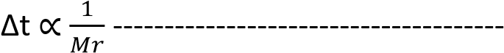 b

or 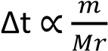

It follows that depression of freezing point is proportional to the number of moles of a solute and if the same number of moles were present for a different solute, in the same mass of solvent, the freezing point depression would be the same.

Cryoscopic constant From b,
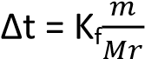
When m =Mr, ∆t=K_{f}
The constant of proportionality K_{f} is called the cryoscopic constant of the solvent.

Definition
Cryoscopic constant (K_{f}) is the amount by which the freezing point of 1000g of a solvent is lowered by 1 mole of solute; assuming rules a and b still hold at this concentrations.

The cryoscopic constants for commonly used solvents are

Solvent K_{f}/⁰Cmol⁻¹
Water 1.86
Benzene 5.12 Ethanoic Acid 3.5
Camphor 40.0

Note: cryoscopic constants are sometimes given for 100g of solvent. E.g. for 100g of water = 18.6⁰Cmol⁻
1
.

Determination of cryoscopic constant
The rationale of the experiment is to determine the freezing point of a dilute solution of a nonvolatile solute and the work out the freezing point depression of a solution containing 1mole of a solute in 1000g of solvent.

The major problem is that the depression of freezing point of a solvent is usually very small thus, a very sensitive thermometer like Beckmann’s thermometer is required.

A. Beckmann’s procedure
- A given mass of the solvent (m₁) is placed in glass tube A into which a thermometer is immersed. This tube is fitted with a wire stirrer, s₁, and a side arm, m, through which the solute can be introduced.
Apparatus


C

m
A

B

S
1

S
2

Beckmann’s thermometer

- the tube A is surrounded by a wider tube, B, which provides an air jacket to ensure uniform cooling
- The freezing agent is contained in vessel C consisting of a mixture of ice and salt and is kept stirred by stirrer S₂.
- The freezing point of the pure solvent T₁, is determined by stirring both freezing agent and the solvent and recording the constant temperature at which a liquid turns into a solid.
- After determining the freezing point of a solvent the solid is warmed to melt.
- A given mass of solute m₂ is introduced into the solvent through side arm, m, and stirred until completely dissolved.
- Repeat procedure 4 and note the temperature (T₂) at which pure solvent alone separate out from solution as solid.

Treatment of results
Mass of solvent = M₁
Mass of solute = m₂
∆t = (T₁-T₂)
Molecular mass of solute = Mr

Mass of solute in 1000g of solvent 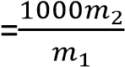
Then,
K_{f} 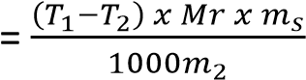 where K_{f} is the cryoscopic constant of a solvent.

B. Rast’s method
This is based on the use of melted camphor as a solvent because it has un usually high cryoscopic constant. An ordinary (360 degree) thermometer is used instead of Beckmann’s thermometer.



xxxxxxxxxxxxxxxxxxx

thermometer

slit

oil bath

solvent/solution

ga
uze on
tripod stand

heat

The procedure consists essentially of measuring the melting point of pure camphor and that of the mixture as described in Beckmann’s procedure.

Limitation of the cryoscopic method
A correct value for relative molecular mass (that is a value corresponding to the actual molecular formula) is obtained under the following conditions.
- When the solution freezes, the pure solvent alone must separate out.
- There must be no chemical reaction between solute and solvent. For example, the formula mass of phosphorous pentachloride cannot be determined using this method in water because the two react.
- The dissolved substance must not dissociate or associate appreciably. Thus this method is not suitable for strong electrolytes, acids and bases.

When the solute dissociates the number particles in solution increase causing the apparent molecular mass of the solute to decrease.

When the solute associate the number of solute molecules in solution decrease, the apparent molecular mass will be greater than the actual value
For example, the apparent relative molecular mass of ethanoic acid in benzene is double because two molecules of ethanoic Acid associate to give one molecules.

- The solution must be dilute.
- The freezing point method is not suitable for determining the molecular mass of polymers because the freezing point depression for dilute solution of the polymers is negligible.

Example 10
0.55g of nitrobenzene in 22g of ethanoic acid depresses the freezing point of the latter by 0.78⁰C. Calculate the relative molecular mass of nitrobenzene. [The cryoscopic constant for 1000g of ethanoic acid is 3.90⁰Cmol⁻¹]

Solution
Mass of nitrobenzene in 1000g of ethanoic acid
22g of benzene contain 0.55g of nitrobenzene
1000g of benzene will contain 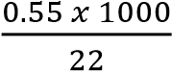 = 25g

Formula mass of nitrobenzene
A depression of 0.78⁰C is caused by
25g of nitrobenzene
Thus, 3.90⁰C will be caused by 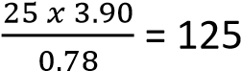
Therefore, molecular mass nitrobenzene = 125g.

Example 11
0.72g of a compound X was dissolved in 80g of water and the resultant solution had a freezing point of 0.14⁰C. When 2.9g of the same compound was dissolved in 11g of benzene, the depression was 6⁰C. [K_{f} for water is 1.86 ⁰Cmol⁻¹kg⁻¹ and K_{f} for benzene is 5.5⁰Cmol⁻¹kg⁻¹.)
(a) Calculate the apparent molecular mass of X in
- water
- Benzene
(b) comment on the results

Solution
(a) (i) mass of X in 1000g of water
80g of water contain 0.72g of X
1000g of water will contain 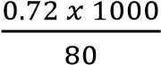 = 9g

Freezing Point depression = 0 – (-.14)
= 0.14⁰C

Formula mass of X

Depression of 0.14⁰C is caused by 9g of X 1.86⁰C will be caused by 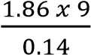 = 120g the apparent molecular mass of X in water
= 120g (b) (a)(ii) mass of X in 1000g of benzene
11g of benzene contain 2.9g of X
1000g of water will contain 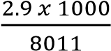 = 263g

Freezing Point depression = 6⁰C

Formula mass of X
Depression of 6⁰C is caused by 263g of X
5.5⁰C will be caused by 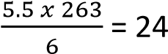 1g
the apparent molecular mass of X in benzene
= 241g
(b) the apparent molecular mass is X is in benzene is double that in water probably because two molecules of X associate in benzene to give one molecule. Or one molecule of X dissociates into two particles in water.
Trial 37
- A solution containing 4.50g of solute B dissolved in 125g of water freezes at -0.372⁰C. Calculate the formula mass of B (Kf for water is 1.86⁰Cmol⁻¹per 1000g) (4marksk)
- How do you expect the formula mass of B to change it ionized in water explain your answer?(2mk)

Solution to trial 37
(a)(i) Mass dissolved in 1000g of water = 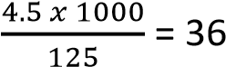g
t = 0 – (-0.372) = 0.372
0.372 is caused by 36 g of B
1.86 is caused by Mr of B
Mr = 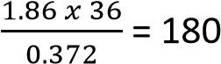
(a)(ii) The apparent molecular mass reduces because the number of particles in solution increase.

(b)(i) Describe how the molecular mass of a substance can be determined using the depression of the freezing point method.
(ii) State two limitations of the method
- Solution must be dilute
- Solute should not react with solvent
- Solute should not dissociate or associate in solution
- Solute should not be a polymer

(c) Calculate the freezing point of an aqueous solution of urea (CO(NH₂)₂) of concentration 12.0gdm⁻³ at a pressure of 101.3kPa. Assume that the volume of the solute is negligible compared to that of the solution.
[the freezing point depression constant is 1.86⁰Cmol⁻¹kg⁻¹, C= 12, H = 1, O = 16, N=14) Solution
Formula mass of (CO(NH₂)₂) = 12 + 16 + 2(14 + 2) = 60 60g cause freezing depression of 1.86⁰C
12g will cause 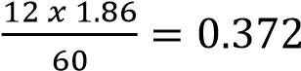
Freezing point = freezing point of solvent - t
= 0 – 0.372
= -0.372⁰C
Trial 38
(a)(i) Describe how the molecular formula of a substance can be determined using freezing point depression method (Diagram not required) (07mks)
(ii) Explain why the method you described in (a)(i) not suitable for determining the molecular mass of a polymer (02marks)
Dilute solutions of polymers have negligible freezing point depression
(b) Calculate the freezing point of a solution containing 4.2g of ethane-1,2-diol (molecular mass = 62) in 30g of water. (K_{f} of water 1.86⁰Cmol⁻¹kg⁻¹) (04mks)

Solution
Mass of ethane-1,2-diol in 1000g of water
30g of water contain 4.2 g
1000g of water contain 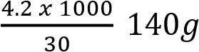
But 62g of ethane-1,2-ol in 1000g of water cause a depression of 1.86⁰C
 140g will cause 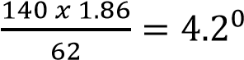
Freezing point of solution = 0 – 4.2 = -4.2⁰C

Trial 39
- Define the term freezing point constant of a substance? ( 1½mk)
- A solution containing 1.54g of Naphthalene (C₁₀H₈) in 18g of camphor freezes at 148.3⁰C. Calculate the freezing point constant of camphor. [The freezing point of camphor is 175⁰C) (3 ½mks)

Solution to trial 39
- Freezing point constant is the freezing point depression caused by one of solute dissolved in 1000g of solvent.
- Formula mass of naphthalene = 12x10 + 8
= 128
Freezing point depression = 175-148.3
= 26.7⁰C
Mass of naphthalene in 1000g of camphor
18g of camphor contain 1.54g of naphthalene
1000g of camphor contain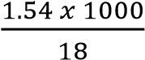 = 85.56g

Freezing point constant
85.56g of camphor cause a depression of 26.7⁰C
128g of naphthalene cause 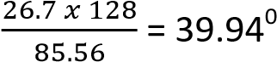C
the freezing constant of camphor
= 39.94⁰Cmol⁻¹kg⁻¹

Trial 40
- One of the limitations of determining relative molecular mass by freezing point method is that the solute should not associate or dissociate in solution
  - State three other limitation of determining molecular mass by freezing point method. (1 ½ marks)
  - Explain how association of solute in solution affects the molecular mass determined by freezing point method (3 ½ marks)
- A solution0.142 g of naphthalene in 20.25 of benzene caused a lowering of freezing point of 0.284⁰C. Calculate the molecular mass of naphthalene. (Cryoscopic constant Kf of benzene is 5.120Cmol⁻¹kg⁻¹)

Solution
(a)(ii) association increases relative molecular mass of a solute because it reduces the number of particles in solution.
(b) 126

Trial 41
A solution containing 28.145g of R in 250 g of water froze at -3.49⁰C. Determine the molecular mass of R. (freezing point constant, Kf of water is 1.86⁰C mol⁻¹ per 1000g) [60]

Trial 42
The cooling curve of a solution containing 1.2g of sulphur in 20 g of carbon disulphide and that of pure carbon disulphide are shown in figure below

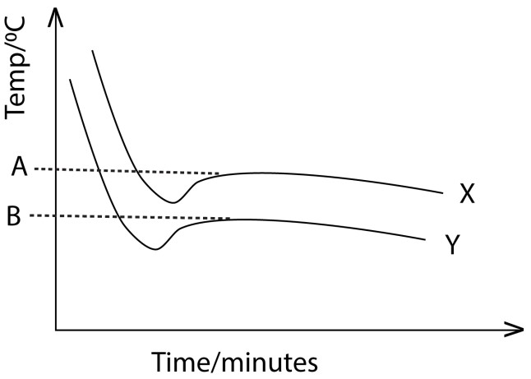

- (i) identify the curve X and Y (1mark)
(ii) State what is represented by the points A and B. (01mark)
- Calculate the relative molecular mass of sulphur in carbon disulphide. (The freezing point depression constant for carbon disulphide is 6.10⁰Cmol⁻¹kg⁻¹ and freezing point depression of carbon disulphide was 1.43⁰C).

Solution to trial 42
(a)(i) X = solvent, Y – solution
(ii) A- freezing point of solvent
B – freezing point of solution
(b) 256

2. Elevation of Boiling point
When a substance a nonvolatile solute is dissolved in a solvent, the boiling point of the solution is raised above the boiling point of the solvent in accordance to the following rules:
- Elevation of boiling point of a given mass of solvent is proportional to mass of a solute dissolved.
- Elevation of boiling point for a given mass of solvent is inversely proportional to the molecular mass of the solute.
Thus, is the mass (m) of a solute of relative molecular mass (Mr) dissolved in a given amount of solvent cause a freezing point depression (∆t) degrees Celsius

then ∆t m---------------------------------------- (a)
It follows that elevation of boiling point is proportional to the number of moles of a solute and if the same number of moles were present for a different solute, in the same mass of solvent, the Elevation of boiling point would be the same.

Ebullioscopic/boiling point constant Kb From (a) and (b),
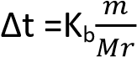
When m =Mr, ∆t=K_{b}
The constant of proportionality K_{b} is called the boiling point constant of the solvent.

Definition
Boiling point constant (K_{b}) is the amount by which the boiling point of 1000g of a solvent is raised by 1 mole of solute; assuming rules (a) and (b) still hold at this concentration.
The boiling point constants for commonly used solvents are
Solvent K_{f}/⁰Cmol⁻¹
Water 0.51
Benzene 2.67
Ethanoic Acid 3.08

Limitation of this method in determination of the relative molecular masses of substance
- Solution must be dilute
- Solute should not react with solvent
- Solute must not associate or dissociate in solution
- Substance must be stable at boiling point of the solution and non-volatile
- It is not suitable for determination of molecular masses of polymers because dilute solutions of polymers, produce negligible boiling point elevation.

Method for determining the boiling point elevation
The main difficult for finding molecular masses by this method arises from super heating of the liquid above its true boiling point. This can be minimized by the following methods.
A. Cottrell’s method


B

A

c

D

Beckmann’s thermometer

solvent/solution

To condenser

Inner tube

Outer tube

side arm

- The solvent is heated in a wide tube, A, fitted with a side arm leading to a reflux condenser which condenses the vapor of the boiling solvent and returns it to the boiling tube.
- A is closed by a stopper, through which passed a second tube B, open at the lower end. B contains a Beckmann thermometer.
- The bulb of the thermometer is above the liquid and protected by the inner tube from drops of condensed liquid falling to it from the side arm.
- Partially immersed in liquid is the Cottrell’s ‘pump’, C, consisting of small inverted glass funnels with a step which divides into two narrow tubes. These are bending around at the top so that, when the liquid boils, the vapor forces the liquid to rise up the narrow tube and spray the bulb of the thermometer. This prevents super heating, and as further precaution is a platinum wire sealed through the bottom of the tube A at D. Heating is by micro burner, which is shielded from draught.
- First, we read the Beckmann thermometer for boiling point (T₀) a known mass (m_{s} g) of solvent. Then we introduce a weighed solute (mass M₂ g) through the side arm and determine the boiling point (T₁) of the solution.

This method can be used to determine the molecular mass of benzoic acid dissolved in acetone or that of naphthalene dissolved in chloroform.

Treatment of results
Mass of solvent = m_{s} Mass of solute = m₂
∆t = (T₁-T₀)
Molecular mass of solute = Mr
Mass of solute in 1000g of solvent 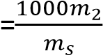
Then,
Kb 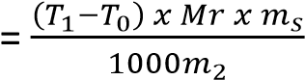

where K_{b} is the boiling point constant of a solvent.

Lands Berger’s method



thermometer

to condenser

Graduated tube

solvent

vapor

E

B

- The solvent is boiled in a separate flask. The vapor passes into the solution which is contained in a graduated tube; surrounded by a second tube.
- The solution is raised to its boiling point by the latent heat of condensation of the solvent vapor.
- When the solution boils the solvent vapor passes through the solution without condensing. It passes through a hole, E, in the boiling tube so that the latter becomes jacketed with the vapor of boiling solvent. Thus reducing radiation to the minimum.
- The bulb B on the inner tube prevent a liquid from being splashed through E.
- The boiling point (T₀⁰C) of pure solvent is first found and then a known mass of a solute (m₂g and formula mass Mr) is introduced and the boiling point (T₁⁰C) of solution is found.
- The final volume of the liquid in the graduated tube is read of and from the density of the solvent the mass (m_{s}g) of the solvent into which a solute is dissolved is calculated.

Then the boiling point constant Kb is given by

Kb =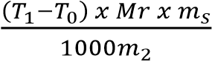

NB. The reason why steam at 100⁰C raises the temperature of the solution above 100⁰C is that steam at 100⁰C has a higher vapor than a solution at the same temperature, it forms a layer above the solution condensing at the surface of the solution and the latent heat evolved would increase the temperature of the solution. The same situation exists when steam is bubbled through the solution.

Example 12
The boiling of ethanol is 78⁰C. Calculate the boiling point of the solution containing 2.7g of ethanamide
(CH₃CONH₂) in 75g of ethanol. (Boiling point elevation constant for 1000g of ethanol = 1.15⁰Cmol⁻¹kg⁻¹) Solution
Mass of ethanamide in 1000g of ethanol
75g of ethanol contain 2.7g of ethanamide
1000g of water will contain 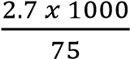 = 36g

Formula mass of CH₃CONH₂ = 59

Boiling Point elevation
59g of ethanamide cause elevation of 1.15⁰C
⇨ 36g of ethanamide cause 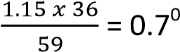C
The boiling point of the solution = (78 +0.7) (bpt of solution is higher than that of solvent by ∆t)
= 78.7⁰C
Trial 43
5.5g of a non-volatile substance was dissolved in 125g of a solvent. The vapor pressure curves for the solution and pure solvent at constant pressure P are shown below:


Pressure

mmHg
)
(

100

100.139

Temperature (
0
C)

P

X

Y

- Identify the curve for the solution
- Calculate the molecular mass of B [the boiling point elevation constant for the solvent K =
0.52⁰Cmol⁻¹kg⁻¹)
- State two limitation of your calculation in (b)

Solution to trial 43
- curve y
- 164 (note that ∆t =(100.139-100)= 0.139⁰C from the graph.)
- any two of the limitations of the boiling point method; except that of B being nonvolatile because this is already mentioned in the question.

Trial 44
- State Raoult’s law (2marks)
- Explain what is meant by the term ‘Colligative property’(3marks)
- A substance was dissolved in a solvent X . the graph below shows how the vapor pressure of the solution and that of pure X vary with temperature



Vapor pres
sure

mmHg
)
(

Atmospheric
pressure

A

C

B

D

E

Temperature/
0
C

- State what points A,B, C, D, E and line AB and AC represent
- Show how the graph can be used to derive an expression for calculating the molecular mass of a solute (12marks)

(d) A solution was prepared by dissolving 7.5g of propan-1,2,3-triol,C₃H₈O₃ in 200g of water at
25⁰C.Calculate the boiling point of the solution at atmospheric pressure (Kb = 0.52⁰C)
Solution to trial 44
(c) (i) A- Vapor pressure of the solvent equal to the atmospheric pressure B- vapor pressure of the solution at the boiling point of the solvent
- vapor pressure of the solution equal to atmospheric pressure
- boiling point of the solvent
- boiling point of solution
AC- elevation of boiling point of solution
AB - depression of the vapor pressure of the solution
(ii) Applying principles of lowering vapor pressure
If m₁ is the mass of the solute of molecular mass Mr₁ dissolved in m_{s} grams of a solvent of molecular mass Mr_{s} to form a dilute solution
then 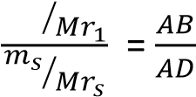
Mr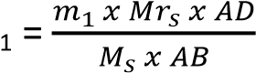

Alternatively, applying principles of elevation of boiling point
If m₁ is the mass of the solute of molecular mass Mr₁ dissolved in m_{s} grams of a solvent of boiling point constant K_{b} ⁰Cmol⁻¹kg⁻¹ to form a dilute solution

Mass of solute in 1000g of solvent = 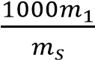

thus, 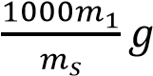 of solute cause boiling point elevation of (E-D)

Mr₁ g cause and elevation K_{b}

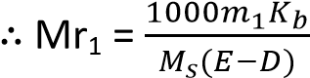

(d) 100.2⁰C

Trial 45
A solution contains 50g of ethane-1,2-diol and 40g of water
- Calculate the boiling point of the solution (H=1, O=16, C=12,K_{b(water)} = 0.52Kmol⁻¹kg⁻¹) (4marks)
- State any assumption you made in the calculation (2marks)

Solution
The formula mass ofethane-1,2-diol,

= 62
Mass of ethane-1,2-diol in 1000g of water
40g of water contains 50g ofethane-1,2-diol
1000g of water contain = 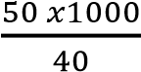 =1250g

Elevation of the boiling point
62g cause boiling point elevation of 0.52⁰C
1250g would cause boiling point elevation
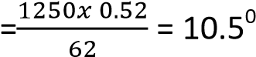C
Boiling point of the solution = 100 + 10.5
= 110.5⁰C
(b) – ethane-1,2-diol is non volatile
- ethane-1,2-diol does not react with water
- it is stable at the boiling point
- it does not associate or dissociate in water

Trial 46
1.455g of a compound Y was dissolved in 80g of ethanol. The boiling point of the solution was 78.97⁰C while that of ethanol was 78.8⁰C (Kb for ethanol is 1.15⁰Cfor 1mole in1000g). Calculate the molecular mass of Y in ethanol (4marks) [123]
Trial 47
- State what meant by the term boiling point constant of a liquid. (2marks)
- Describe an experiment that can be used to determine the relative molecular mass of a compound using the method of elevation of the boiling point of a liquid. Draw a labeled diagram of the apparatus used. (12marks)
- Explain why the method you have described in (b) is not suitable for determination of the relative molecular mass of ethanoic acid in aqueous solution. (03marks)
- A solution of 2.8g of cadmium (II) iodide in 20g of water boiled at 100.20C at normal pressure. Calculate the relative molecular mass of cadmium II iodide and comment on your results. [The boiling point elevation constant for water is0.52⁰Cmol⁻¹kg⁻¹) (03marks)

Solution
- Boiling point elevation constant is elevation of boiling point cause by 1 mole of a solute dissolved in 1000g of solvent.
- A given mass X g of a solute of molecular mass, Mr, is dissolves in Y g of solvent whose boiling point is T₀ ⁰C and boiling point elevation constant Kb. The boiling point of the solution T ⁰C is determined.


Freezing point depression = (T – T₀) ⁰C
Mass of solute in 1000g of solvent Y g of solvent contain X g of solute
Therefore, 1000 g of solvent contain 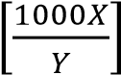 g
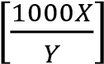 g of solute cause a boiling elevation of (T –T₀) ⁰C.
 g cause boiling point elevation of Kb
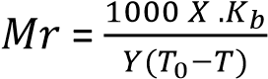

- it is volatile it ionizes in water
- formula mass = 364 (the answer is almost accurate (366) within experimental errors.

Lowering of vapor pressure
The vapor pressure of a liquid at a given temperature is the pressure exerted by it vapor when it is in equilibrium with the liquid.

The vapor pressure of a solution of a nonvolatile solute is usually less than that of pure solvent at a given temperature; because the nonvolatile solute particles occupy part of the solvent surface reducing the escaping tendency of the solvent molecules

Laws of vapor pressure of solution
As with freezing point depression and boiling point elevation; lowering of the vapor pressure of a solvent by a nonvolatile solute at a given temperature is directly proportional to the concentration of the solute and inversely proportional to the formula mass (RFM).

More important than the actual lowering of the vapor pressure is the relative lowering of vapor pressure, 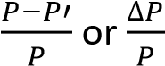 at the same temperature.
Where, P = vapor pressure of the solvent
P’ = vapor pressure of the solution

The relative lowering of vapor pressure is
- independent of temperature
- proportional to the concentration of solute
- Constant if the number of molecules of different solute is dissolved in the same mass of solvent.

Raoult’s vapor pressure law
The relative lowering of vapor pressure is equal to the mole fraction of the solute. If n₁ and n₂ are the number of moles of solute and solvent

Then, 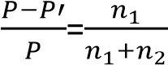 …………………………………….(1)

In a dilute solution, n₁, is negligible compared to n₂, hence n₁+ n₂ ≈ n₂.
Then, 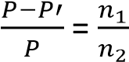 ……………………………..(2)
In m₁ is the mass of the solute in the solvent of mass m₂, and Mr₁ and Mr₂ are the relative molecular massed of the solute and solvent respectively

Then, n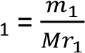 and n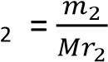

Substituting for n₁ and n₂ in equation (2)
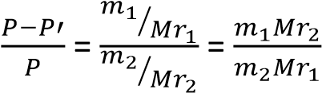 ……………………………………(3)

The vapor pressure law (3) holds true if only the solute is non volatile, the solution is dilute; and the solute does not dissociate or associate appreciably.

Example 13
The vapor pressure of water at 50⁰C is 12333Pa. At this temperature, a solution of 9.14g of carbamide (urea) in 150.0g of water has a vapor pressure of 12106Pa. Find the relative molecular formula of the carbamide.

From,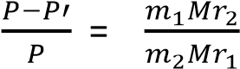
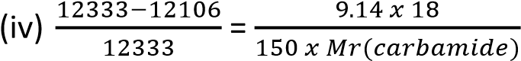

Formula mass of carbamide (Mr (carbamide)

= 59.6

Trial 48
- A solvent Y of molecular mass 62 has a vapor pressure of 1.0 x 10⁴Nm⁻² at 298K. 23.3g of a nonvolatile solute of molecular mass 270 was added to 100g of Y at 298K. Calculate the vapor pressure of solution
- State and explain the effect of increasing the concentration of the solute on the boiling point of Y.

Solution
- Moles of solvent = 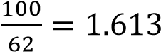 Mole of solute = 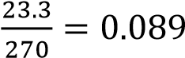 vapor pressure of solution 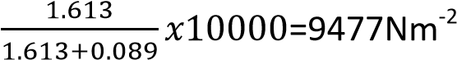
- it increases the boiling point because a nonvolatile solute lowers the vapor pressure of the solution such that the solution has to be boiled at a higher temperature to make its vapor pressure equal to that of the atmospheric pressure to boils.

Trial 14
- the vapor pressure of a solution containing 108.2g of a substance Y in 1000 was reduced by 0.186mmHg of water at 20⁰C
(The vapor pressure of water at 200C is 17.54mmHg. Calculate the relative molecular mass of substance Y. (04marks)
- State four assumptions made in (a)
- Explain why the vapor pressure of the solution containing a nonvolatile solute is less than the vapor pressure of a pure solvent.
Solution

- formula mass of Y =184
- – solution is dilute - solute is nonvolatile
  - solute does not dissociate appreciably
  - solute does not react with solvent
  - solute does not associate in solution
- The nonvolatile solute particles occupy part of the solvent surface reducing the escaping tendency of the solvent molecules

Osmotic pressure method for determining the relative molecular masses of substance.

Definitions
Osmosis is the movement of the solvent molecules from the region where they are highly concentrated to the region of their low concentration through a semi-permeable membrane.

Suppose the solution and solvent are contained in the limbs of a U-tube and a semi-permeable membrane separates a solution from a solvent and that a movable piston is placed on a limb containing the solution. The piston would be observed to rise as the solvent passes through the membrane to the solution. The rise may be prevented by applying just the right external pressure to the piston.

The osmotic pressure of the solution is the minimum pressure which must be applied to the solution to balance the tendency of the solvent to flow from the solvent to the solution side of the semipermeable membrane.

Laws of osmotic pressure
The Dutch scientist Vant Hoff found out that there is a close resemblance between the osmotic pressure and the gas law

PV = nRT

Since the law analogous to Charles and Boyles law apply to osmotic pressure and an expression similar to gas equation πV = nR’T can be deduced for a dilute solution. Where = osmotic pressure, V= volume of the solution, R’= constant which is very close to the gas constant and T is temperature of the solution in Kelvin.

Calculations on the osmotic pressure method are chiefly used to find RFM of polymers that have high molecular mass.

Example 14
An aqueous solution of sucrose containing 19.15g of sugar per dm⁻³ has osmotic pressure of 136,300Pa. Find the Relative Formula mass of sucrose.

Treating the sugar as a gas,
Method 1
We find the volume, V, the gas would occupy at s.t.p.
From 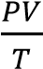 = constant

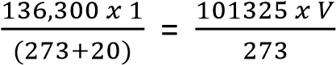

V= 1.254dm³

The molar volume of a gas at s.t.p = 22.4dm³. then, 1.254dm³ of sugar weigh 19.15g 22.4dm³ of sugar will weigh 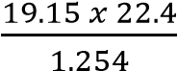

= 342.3 Molecular mass of sucrose = 342.3 Method II
From πV = nR’T , we find the moles of sugar solution in 19.15g, NB: Pressure must be in Pascal, Volume in m³, and temperature in Kelvin π = 136,300Pa
V= 1dm³ = 1x10⁻³m³
R = 8.31
T = (273+ 20)K
Then, n = 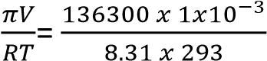 = 0.056moles

Thus, 0.056moles weigh 19.15
1mole weigh 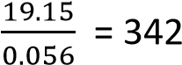

Method III
From πV = nR’T , we find the moles of sugar solution in 19.15g,
NB: Pressure must be in atmospher, Volume in dm³, and temperature in Kelvin, R= 0821 π = 136,300Pa = 136300/101325 = 1.345atm
V= 1dm³
R = 0.0821
T = (273+ 20)K
Then, n = 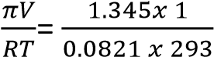 = 0.056mo les

Thus, 0.056moles weigh 19.15
1mole weigh 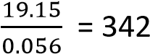

NB. The only problem with the second method is that, there is a need to convert units to standard units of Pressure (Nm⁻²/ Pascal), Volume, (m³), and temperature (Kelvin)

Precautions to osmotic law
- the solution must be dilute
- the solute should not dissociate or associate in solution
- the solute should not react with the solvent
- the temperature should not be very high of very low.

Method of determination of Relative formula mass of a substance by osmotic pressure method

Working Diagram


solven
t

solution 1

2

3

solvent

solution

semi
-
permeable
4

- cylindrical tube between the solvent and solution is porous/semi-permeable
- Pressure is applied to the solution and adjusted until there no flow of solvent into solution.
- Capillary tube indicates movement of solvent into the solution.
- Osmotic pressure, P (Pascal) obtained from the pressure gauge and temperature T⁰C of the solution is determined
Results
Suppose the concentration of the solution is m gdm⁻³
From PV = nRT = 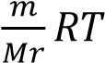 where V is the volume in m³, R = constant = 8.31, Mr= required molecular mass, T is Kelvin temperature
Mr =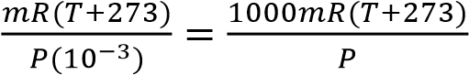

Trial 49
- Define the term osmotic pressure (2 marks)
- The osmotic pressure of a solution containing 42g/l of a substance is 5.62x10⁵Nm⁻² at 20⁰C.Calculate the relative molecular mass of y. (2½mks) [123]

Trial 50
- the osmotic pressure of various concentration of a solute in methylbenzene at 200C are given in the table below
Conc. g/dm³ | 1.0 | 2.0 | 3.0 | 4.0 | 5.0 | 6.0
Osmotic pressure/Nm⁻² | 23 | 37 | 53 | 75 | 92 | 109
- Plot a graph of osmotic pressure against concentration
- Use the graph you have drawn to determine the molecular mass X (R =8.314JK⁻¹mol⁻¹)

Solution
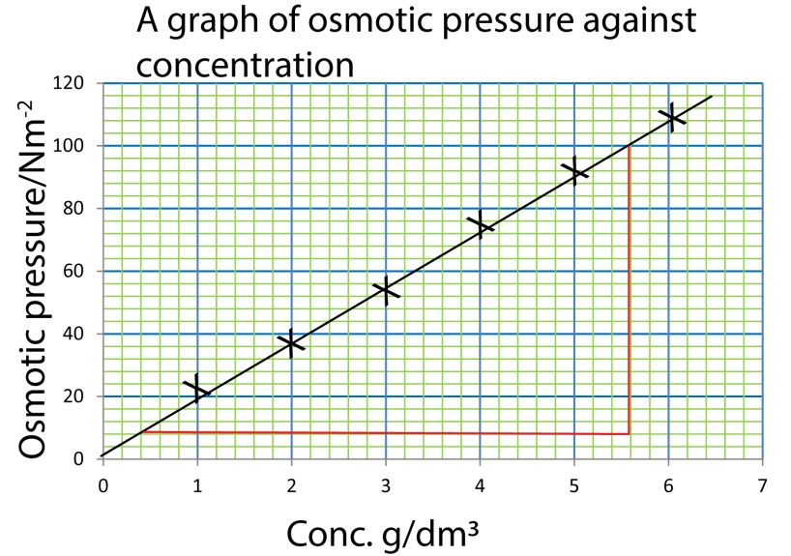

(i)

(ii) From PV = nRT = 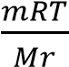
It implies that P 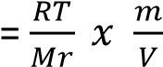
Gradient 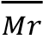 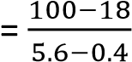
= 17.7

Mr.= 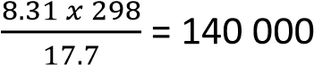

Trial 51
(a) Solution containing20 g of a polymer X in 1l of solution exert an osmotic pressure of 1.4mmHg at
25₀C
- Explain what is meant by the term osmosis. (2mks)
- Calculate the molecular mass of X
- The molecular formula of the monomer of X is (CH₂=CHCN). Determine the number of monomers of X (2mks)
- Draw the general formula of X (1mk)
- Explain why the freezing point depression method is not suitable for determining the molecular mass of a polymer (2mks)
(b) (i)Describe how the molecular mass of a substance can be determined by the freezing point depression method. (06marks)
(ii) Calculate the freezing point depression of the solvent in (a)

Solution
(a)(ii) Molecular mass of X = 265471
(a)(iii) Number of monomer = 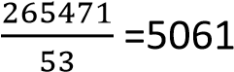
(b)(ii) 3.77x10⁻⁴ ⁰C

Trial 52
- Explain what is meant by the following terms
  - Osmosis (3mks)
  - Osmotic pressure (3mks)
- State the significance of osmosis (1mk)
- Describe a method which can be used to determine the osmotic pressure of a solution (7mks)
- state the conditions under which solutions do not obey the laws of osmotic pressure (3mk)
- The osmotic pressure of a solution containing 1.24% of a polymer is 3.1 x 10⁻³ atmospheres at
25⁰C. Determine the relative formula mass of the polymer. (R-0.0821) (03mks)
Solution
(e) NB. when R=0.0821, Pressure used should be in atmospheres and volume in dm³.
Thus, No. of moles = 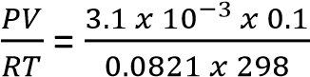
= 1.267 x 10⁻⁵ moles
Then. 1.267 x 10⁻⁵ moles weigh 1.24g
1 mole will weigh 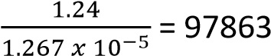 the molecular mass of the polymer = 97863

Trial 53
The osmotic pressure of a solution containing 4g per litre of a polymer is 65Nm⁻² at 298K. Calculate the approximate molecular mass of the polymer. (02marks) [152466]

Trail 54
The osmotic pressure of a solution containing 2gdm⁻³ of nylon 6.10 at 25⁰c is 0.155mmHg. Calculate the relative molecular mass of nylon 6,10. [R = 0.0821atm⁻¹ ⁰Cmol⁻¹] [240000]

